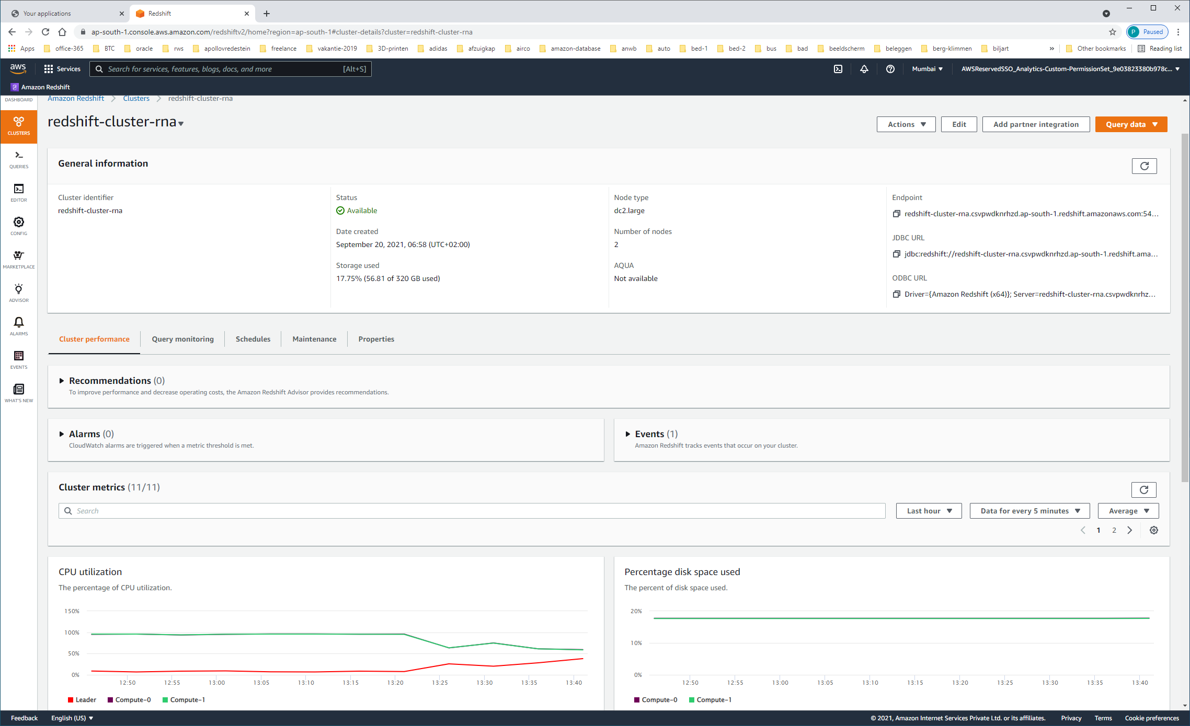

REGION: AsianPacific (Mumbai) = AP-SOUTH-1

Node type dc2.large

Number of nodes 2

redshift-cluster-rna.csvpwdknrhzd.ap-south-1.redshift.amazonaws.com:5439/dev

jdbc:redshift://redshift-cluster-rna.csvpwdknrhzd.ap-south-1.redshift.amazonaws.com:5439/dev

Driver={Amazon Redshift (x64)}; Server=redshift-cluster-rna.csvpwdknrhzd.ap-south-1.redshift.amazonaws.com; Database=dev

Onder PROPERTIES

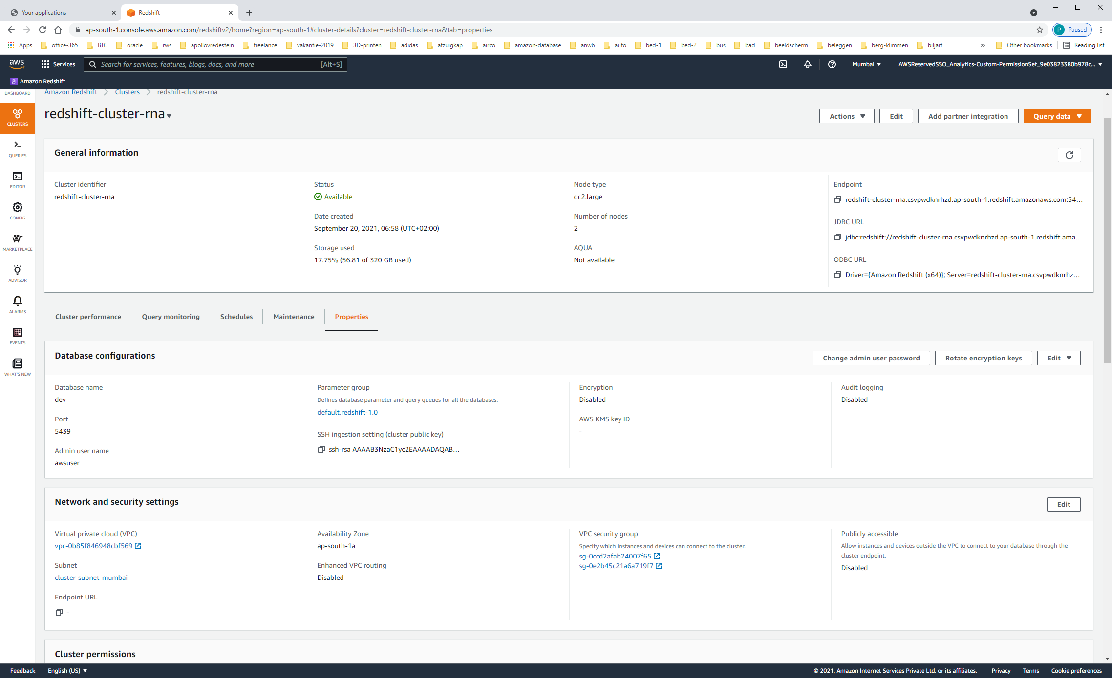

Database name dev

Port 5439

Admin user name awsuser

Scroll door naar beneden…

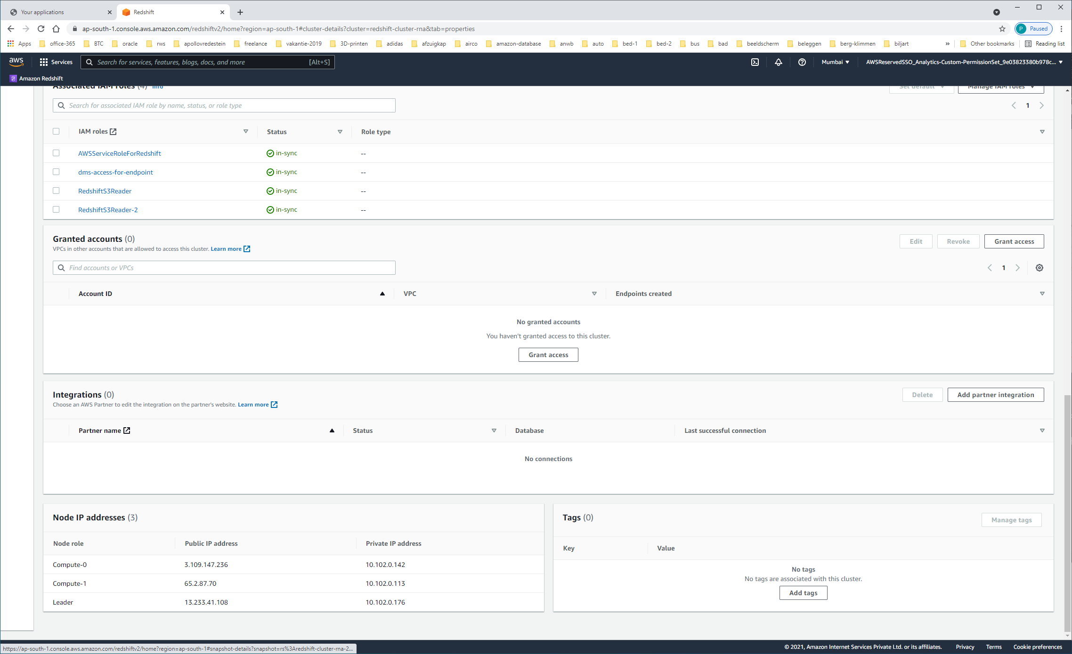

| **Node role** | **Public IP address** | **Private IP address** |
| --- | --- | --- |
| Compute-0 | 3.109.147.236 | 10.102.0.142 |
| Compute-1 | 65.2.87.70 | 10.102.0.113 |
| Leader | 13.233.41.108 | 10.102.0.176 |

SUBNETS

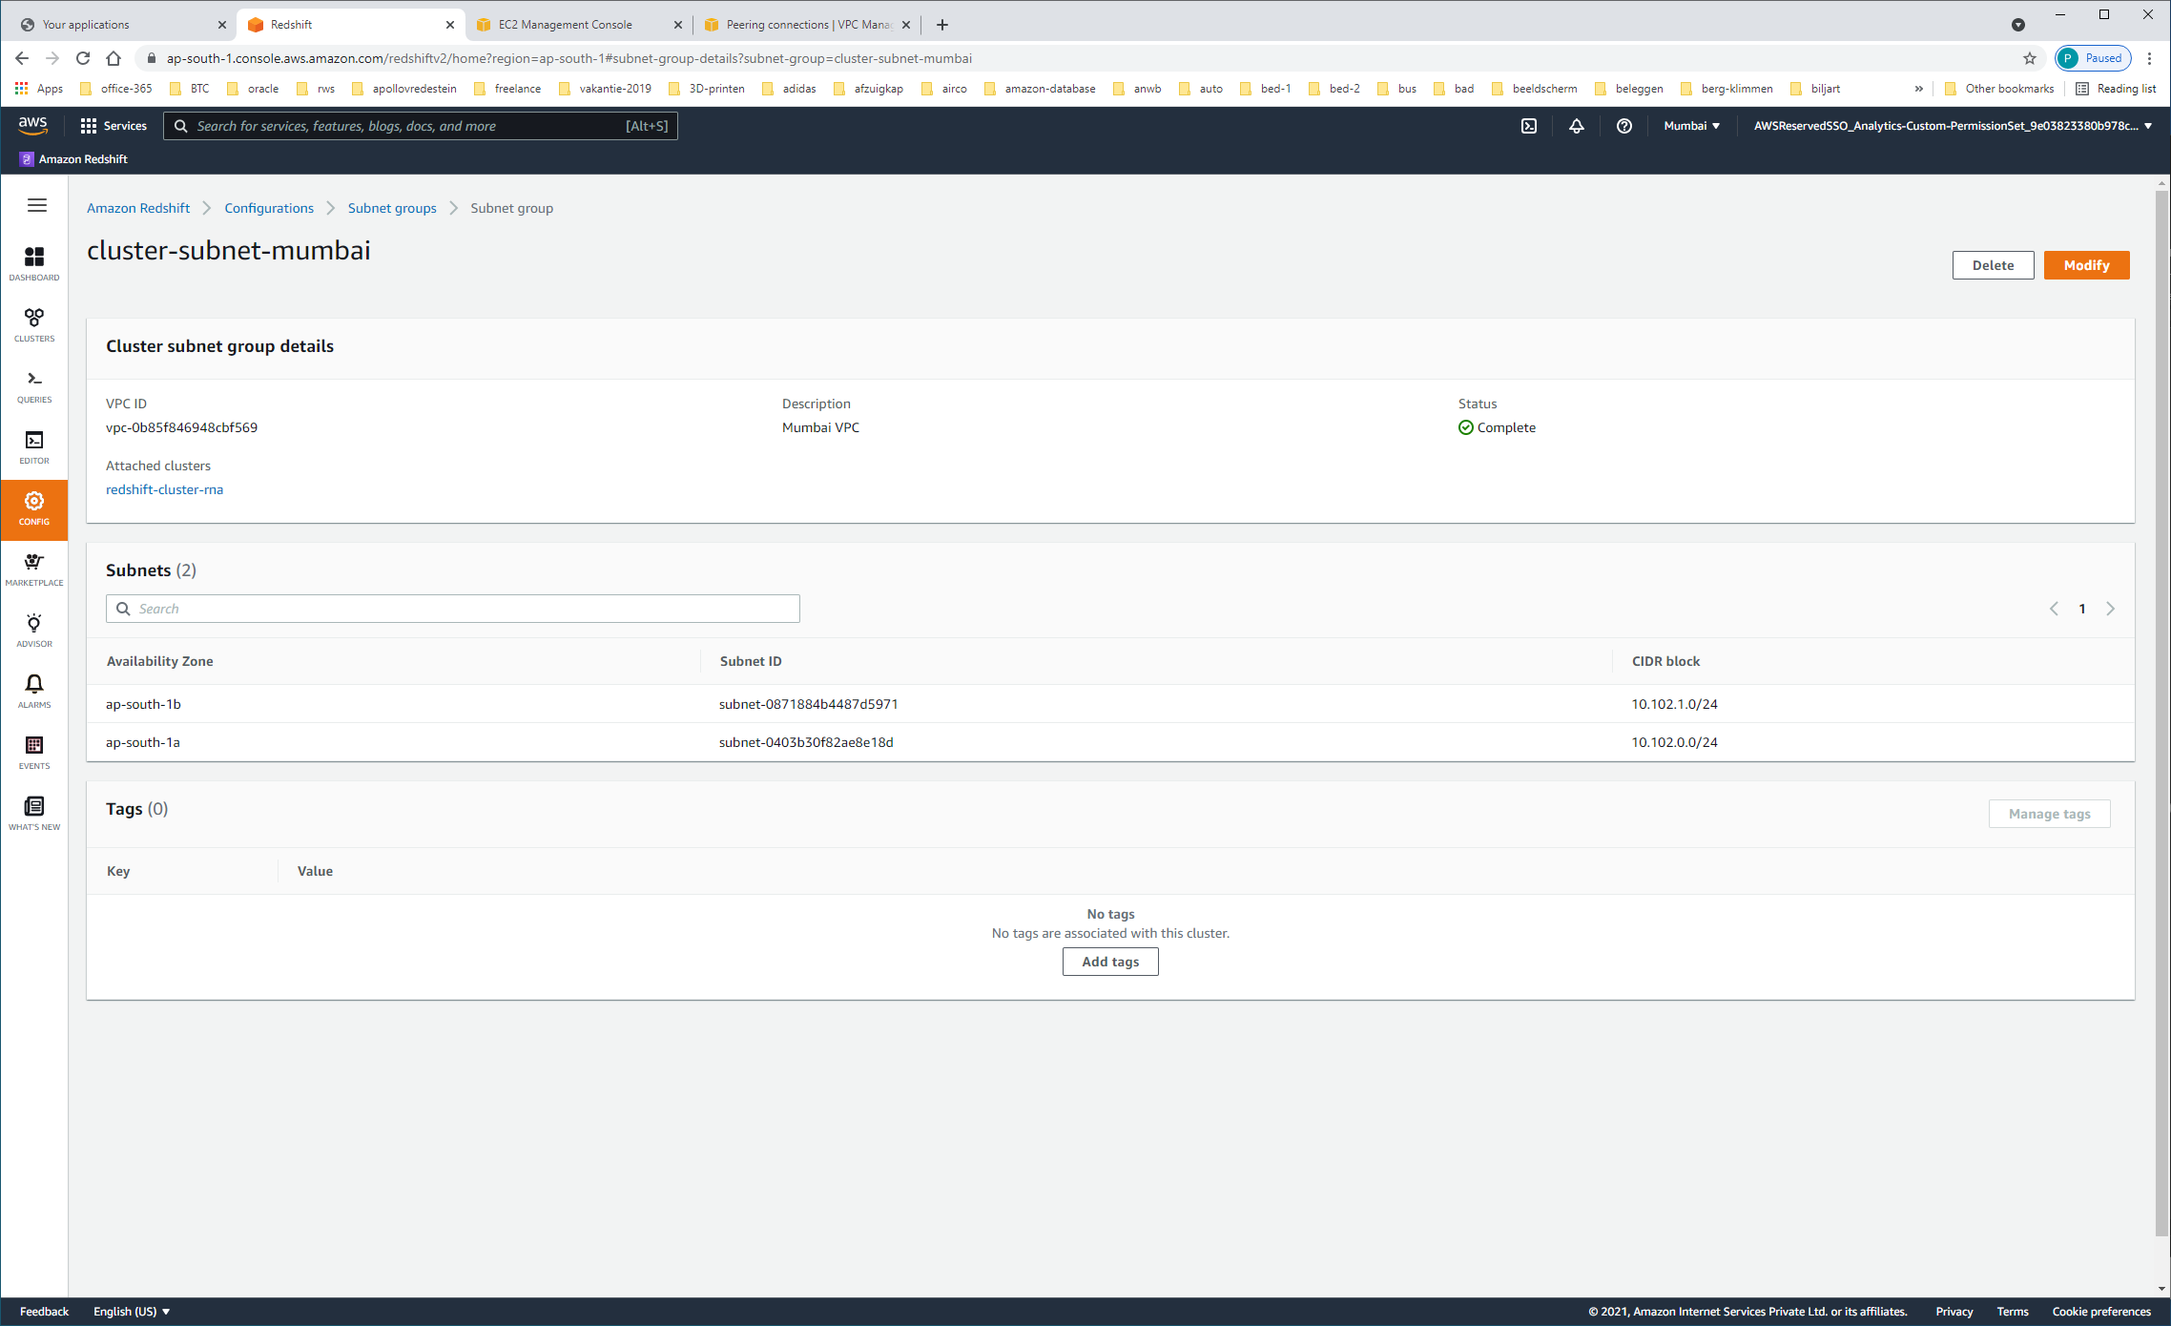

| **Availability Zone** | **Subnet ID** | **CIDR block** |
| --- | --- | --- |
| ap-south-1b | subnet-0871884b4487d5971 | 10.102.1.0/24 |
| ap-south-1a | subnet-0403b30f82ae8e18d | 10.102.0.0/24 |

Vragen we vanuit VPC-DASHBOARD alle SUBNETS op:

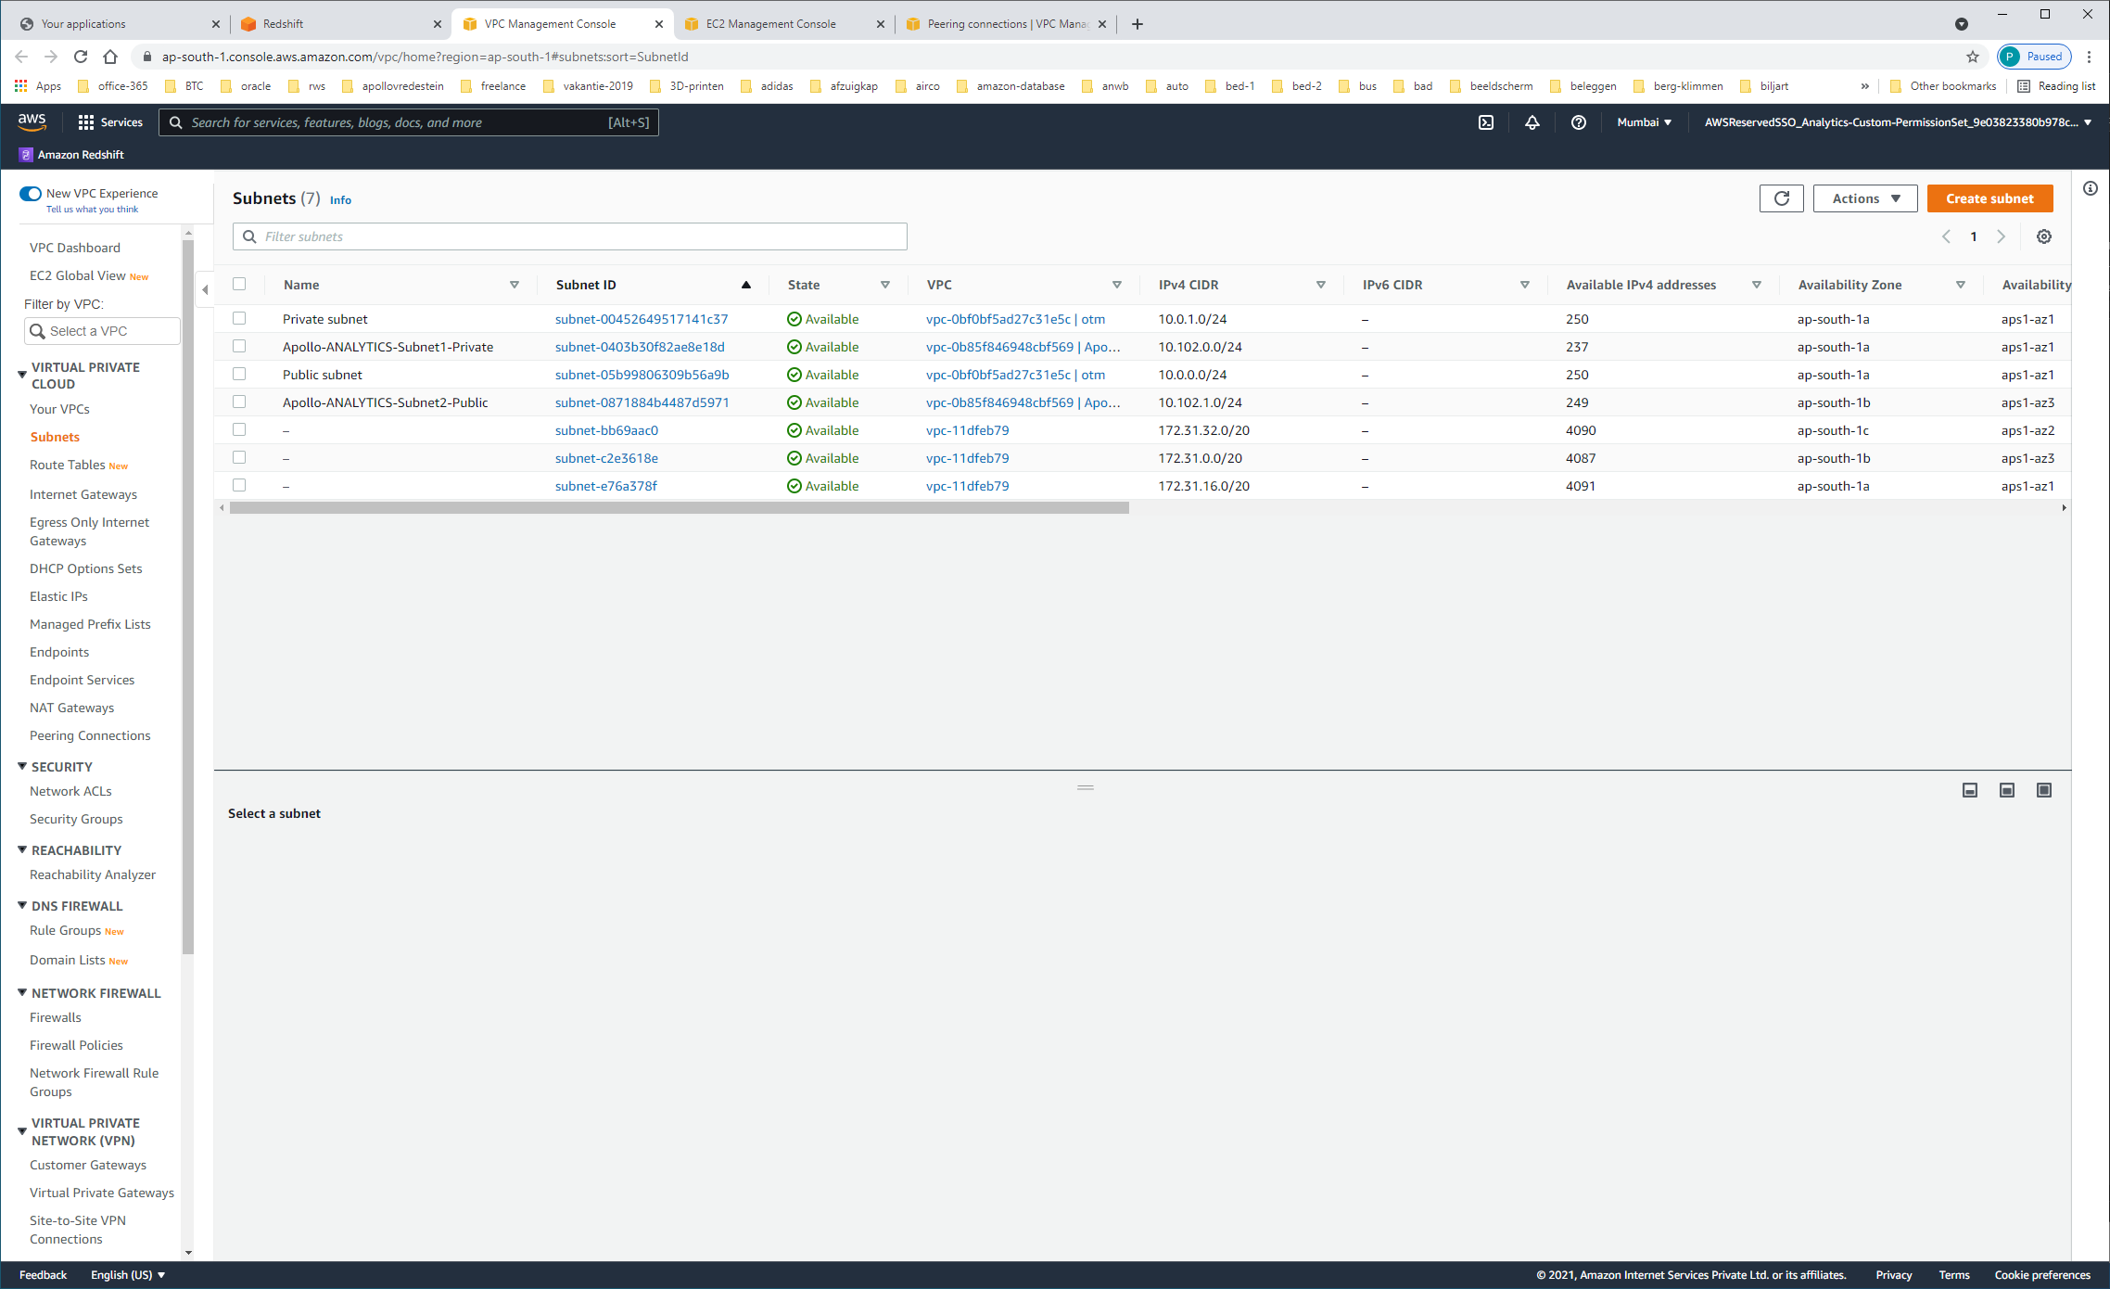

|  |  |  |  |  |
| --- | --- | --- | --- | --- |
| Private subnet | [subnet-00452649517141c37](https://ap-south-1.console.aws.amazon.com/vpc/home?region=ap-south-1#SubnetDetails:subnetId=subnet-00452649517141c37) | Available | [vpc-0bf0bf5ad27c31e5c | otm](https://ap-south-1.console.aws.amazon.com/vpc/home?region=ap-south-1#vpcs:VpcId=vpc-0bf0bf5ad27c31e5c) | 10.0.1.0/24 |
| Apollo-ANALYTICS-Subnet1-Private | [subnet-0403b30f82ae8e18d](https://ap-south-1.console.aws.amazon.com/vpc/home?region=ap-south-1#SubnetDetails:subnetId=subnet-0403b30f82ae8e18d) | Available | [vpc-0b85f846948cbf569 | Apollo-ANALYTICS-VPC-Mumbai](https://ap-south-1.console.aws.amazon.com/vpc/home?region=ap-south-1#vpcs:VpcId=vpc-0b85f846948cbf569) | 10.102.0.0/24 |
| Public subnet | [subnet-05b99806309b56a9b](https://ap-south-1.console.aws.amazon.com/vpc/home?region=ap-south-1#SubnetDetails:subnetId=subnet-05b99806309b56a9b) | Available | [vpc-0bf0bf5ad27c31e5c | otm](https://ap-south-1.console.aws.amazon.com/vpc/home?region=ap-south-1#vpcs:VpcId=vpc-0bf0bf5ad27c31e5c) | 10.0.0.0/24 |
| Apollo-ANALYTICS-Subnet2-Public | [subnet-0871884b4487d5971](https://ap-south-1.console.aws.amazon.com/vpc/home?region=ap-south-1#SubnetDetails:subnetId=subnet-0871884b4487d5971) | Available | [vpc-0b85f846948cbf569 | Apollo-ANALYTICS-VPC-Mumbai](https://ap-south-1.console.aws.amazon.com/vpc/home?region=ap-south-1#vpcs:VpcId=vpc-0b85f846948cbf569) | 10.102.1.0/24 |
| – | [subnet-bb69aac0](https://ap-south-1.console.aws.amazon.com/vpc/home?region=ap-south-1#SubnetDetails:subnetId=subnet-bb69aac0) | Available | [vpc-11dfeb79](https://ap-south-1.console.aws.amazon.com/vpc/home?region=ap-south-1#vpcs:VpcId=vpc-11dfeb79) | 172.31.32.0/20 |
| – | [subnet-c2e3618e](https://ap-south-1.console.aws.amazon.com/vpc/home?region=ap-south-1#SubnetDetails:subnetId=subnet-c2e3618e) | Available | [vpc-11dfeb79](https://ap-south-1.console.aws.amazon.com/vpc/home?region=ap-south-1#vpcs:VpcId=vpc-11dfeb79) | 172.31.0.0/20 |
| – | [subnet-e76a378f](https://ap-south-1.console.aws.amazon.com/vpc/home?region=ap-south-1#SubnetDetails:subnetId=subnet-e76a378f) | Available | [vpc-11dfeb79](https://ap-south-1.console.aws.amazon.com/vpc/home?region=ap-south-1#vpcs:VpcId=vpc-11dfeb79) | 172.31.16.0/20 |

LET OP:

De overige VPC's (VPC-11dfeb79 + vpc-0bf0bf5ad27c31e5c-l-otm) zijn volgens mij niet in gebruik !!

|  |  |
| --- | --- |
| 691959165503 | ATL AWS Root |

Ga via PROPERTIES naar VPC / SECURITY-GROUPS

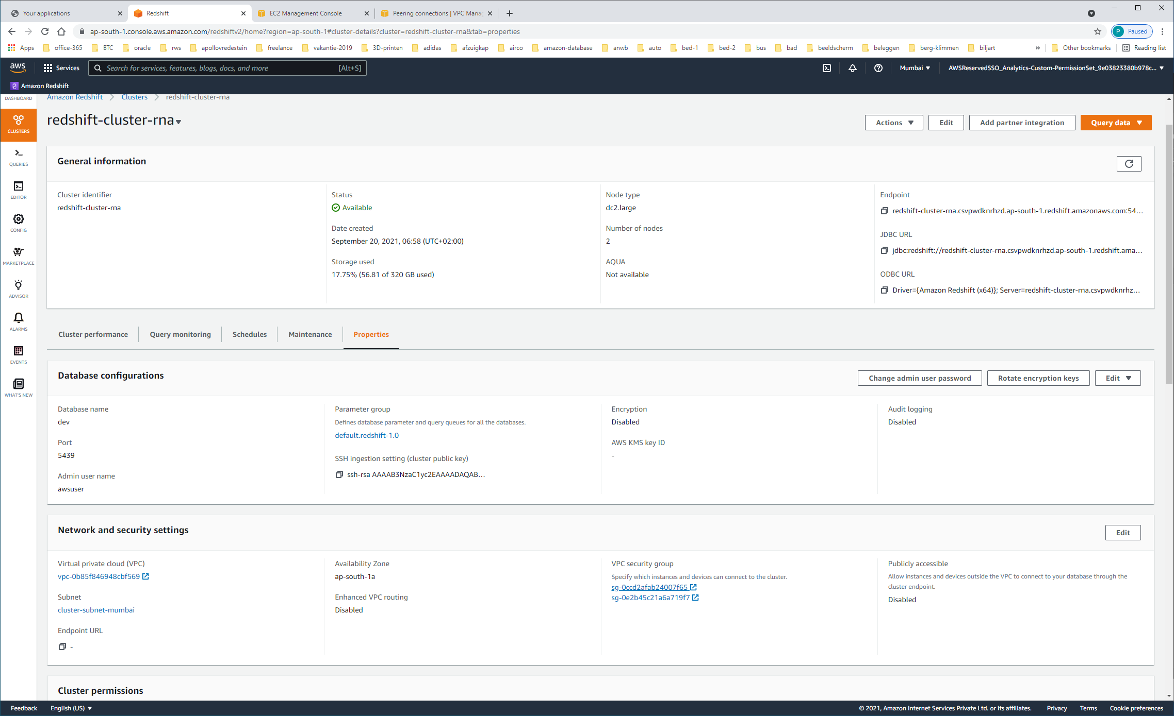

https://ap-south-1.console.aws.amazon.com/vpc/home?region=ap-south-1#RouteTables:routeTableId=rtb-098276a2fae67f9b0

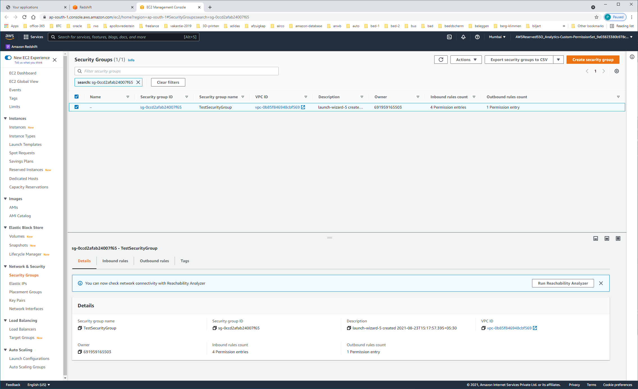

VPC: [vpc-0b85f846948cbf569](https://ap-south-1.console.aws.amazon.com/vpc/home?region=ap-south-1#vpcs:VpcId=vpc-0b85f846948cbf569)

https://ap-south-1.console.aws.amazon.com/vpc/home?region=ap-south-1#vpcs:VpcId=vpc-0b85f846948cbf569

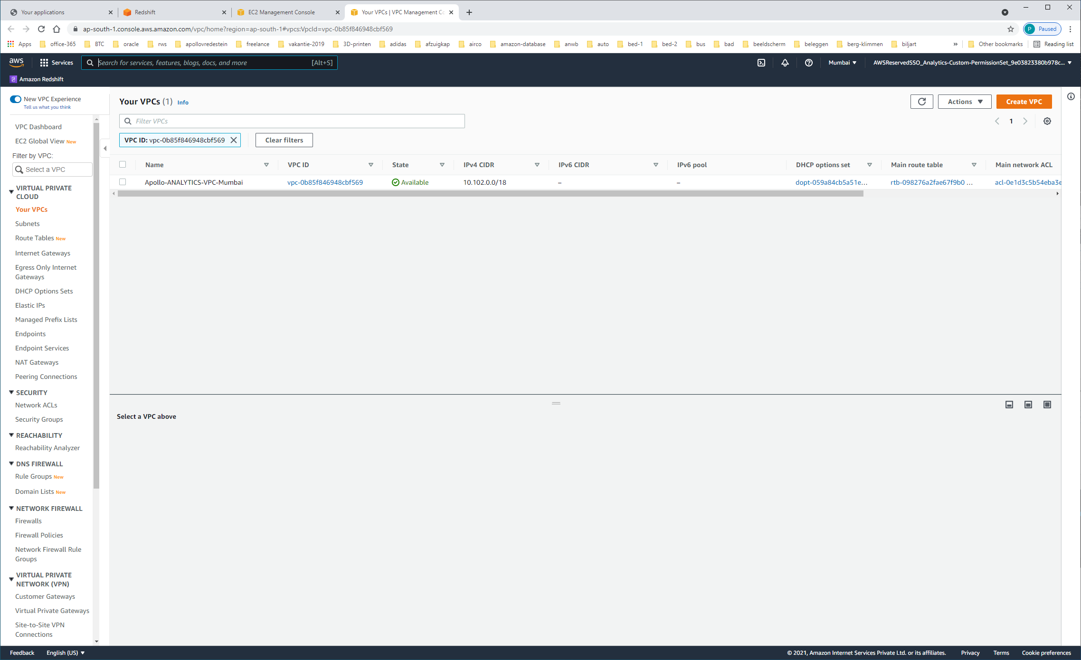

Ipv4: 10.102.0.0/18

ENDPOINTS

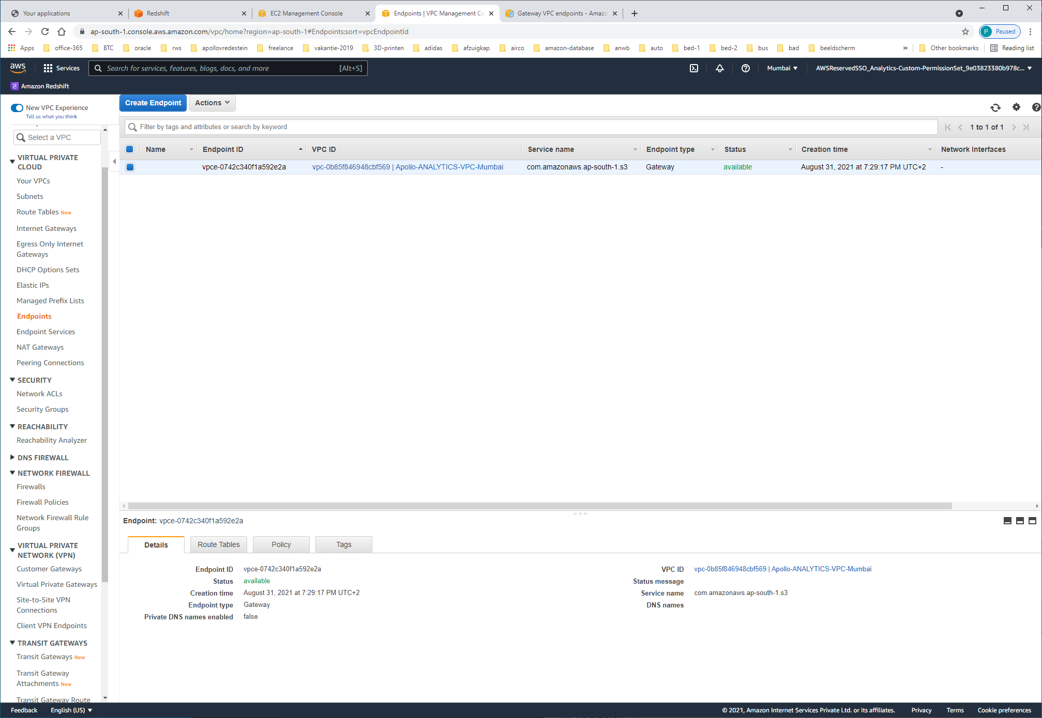

De MAIN-ROUTE-table

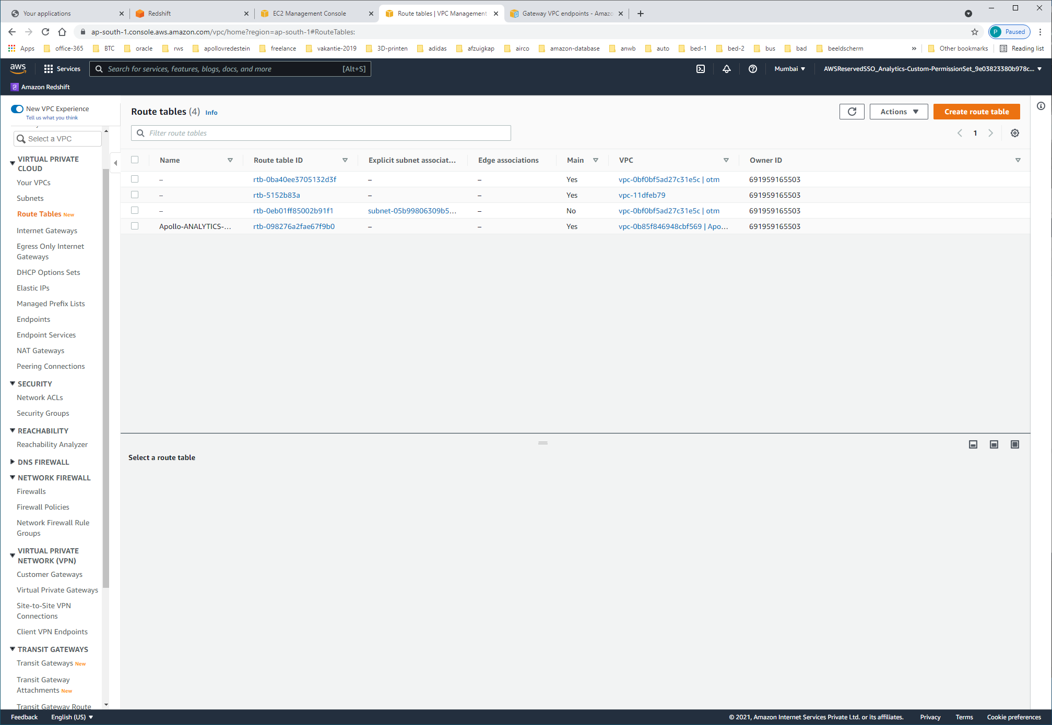

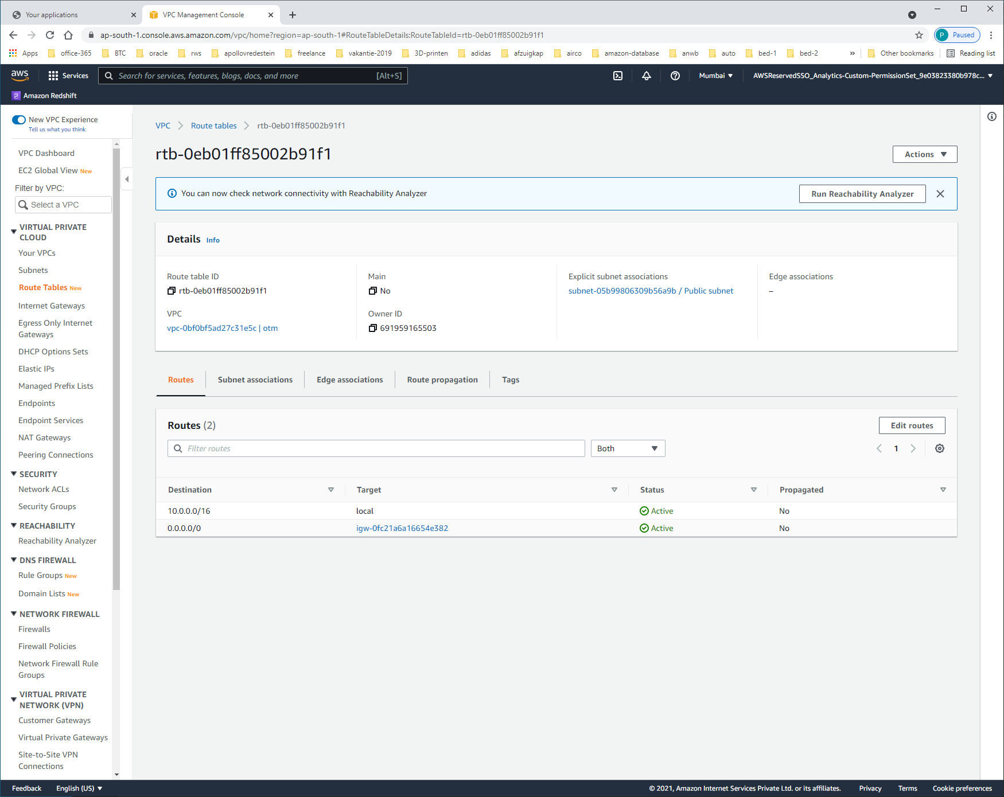

| **Destination** | **Target** | **Status** | **Propagated** |
| --- | --- | --- | --- |
| 10.0.0.0/16 | local | Active | No |
| 0.0.0.0/0 | [igw-0fc21a6a16654e382](https://ap-south-1.console.aws.amazon.com/vpc/home?region=ap-south-1#igws:internetGatewayId=igw-0fc21a6a16654e382) | Active | No |

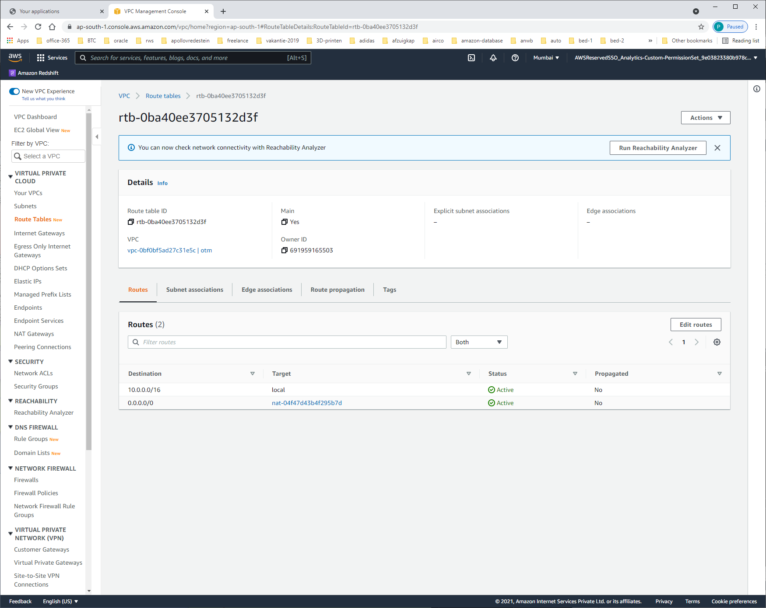

| **Destination** | **Target** | **Status** | **Propagated** |
| --- | --- | --- | --- |
| 10.0.0.0/16 | local | Active | No |
| 0.0.0.0/0 | [nat-04f47d43b4f295b7d](https://ap-south-1.console.aws.amazon.com/vpc/home?region=ap-south-1#NatGateways:natGatewayId=nat-04f47d43b4f295b7d) | Active | No |

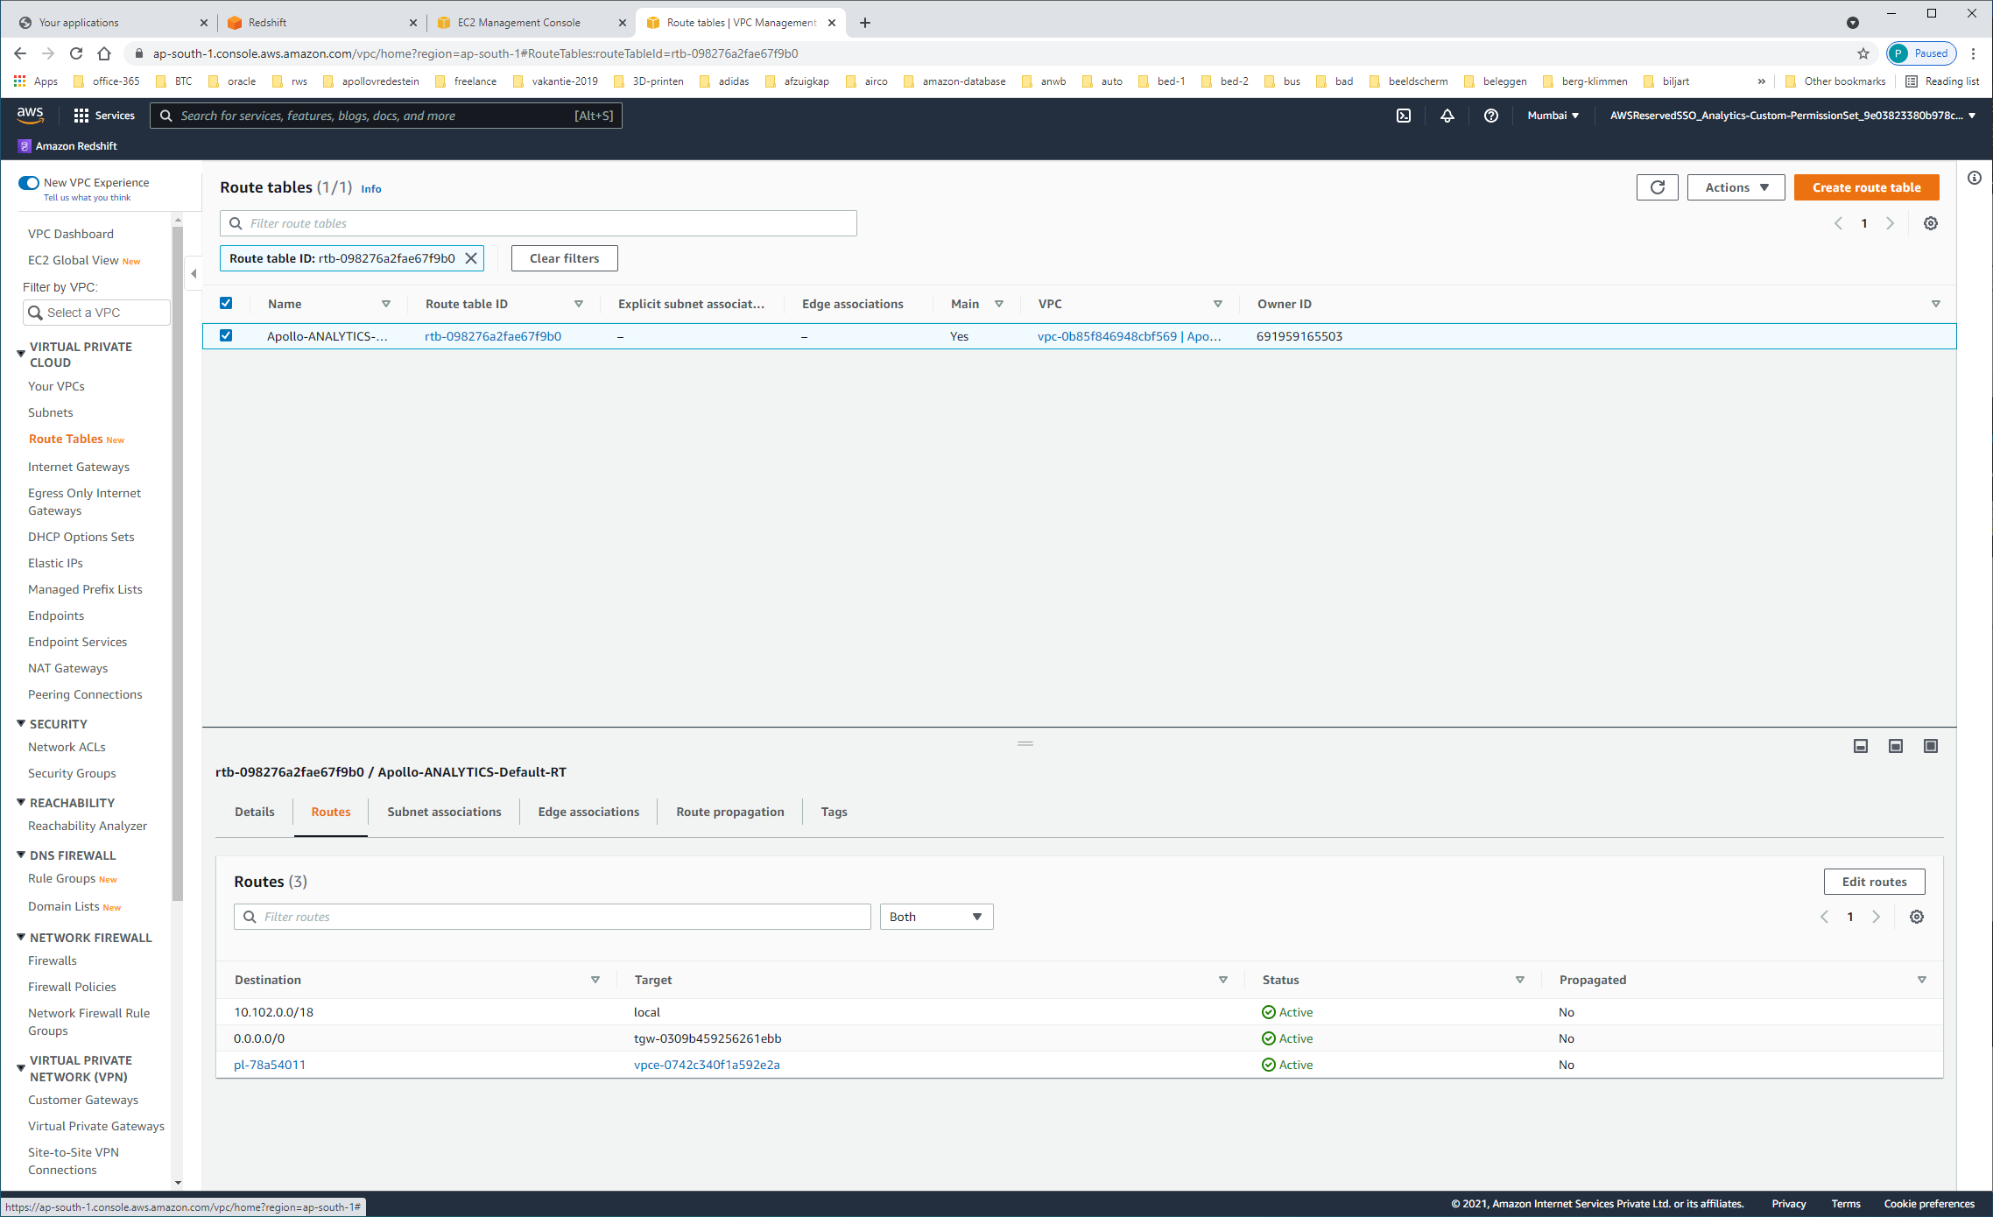

| **Destination** | **Target** | **Status** | **Propagated** |
| --- | --- | --- | --- |
| 10.102.0.0/18 | local | Active | No |
| 0.0.0.0/0 | tgw-0309b459256261ebb | Active | No |
| [pl-78a54011](https://ap-south-1.console.aws.amazon.com/vpc/home?region=ap-south-1#ManagedPrefixLists:PrefixListId=pl-78a54011) | [vpce-0742c340f1a592e2a](https://ap-south-1.console.aws.amazon.com/vpc/home?region=ap-south-1#Endpoints:vpcEndpointId=vpce-0742c340f1a592e2a) | Active | No |

Subnets

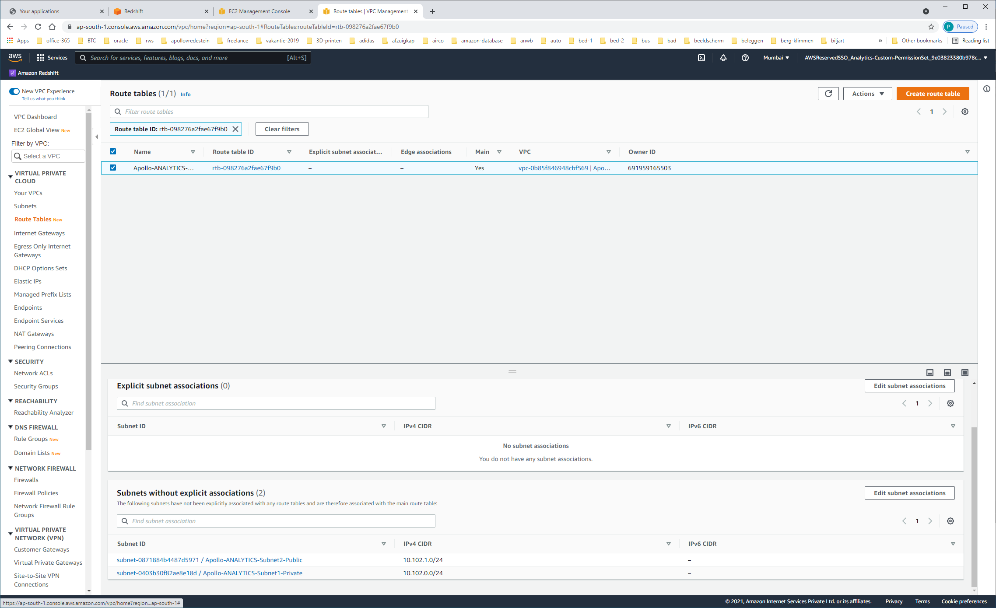

https://ap-south-1.console.aws.amazon.com/vpc/home?region=ap-south-1#igws:

INTERNET-GATEWAYS

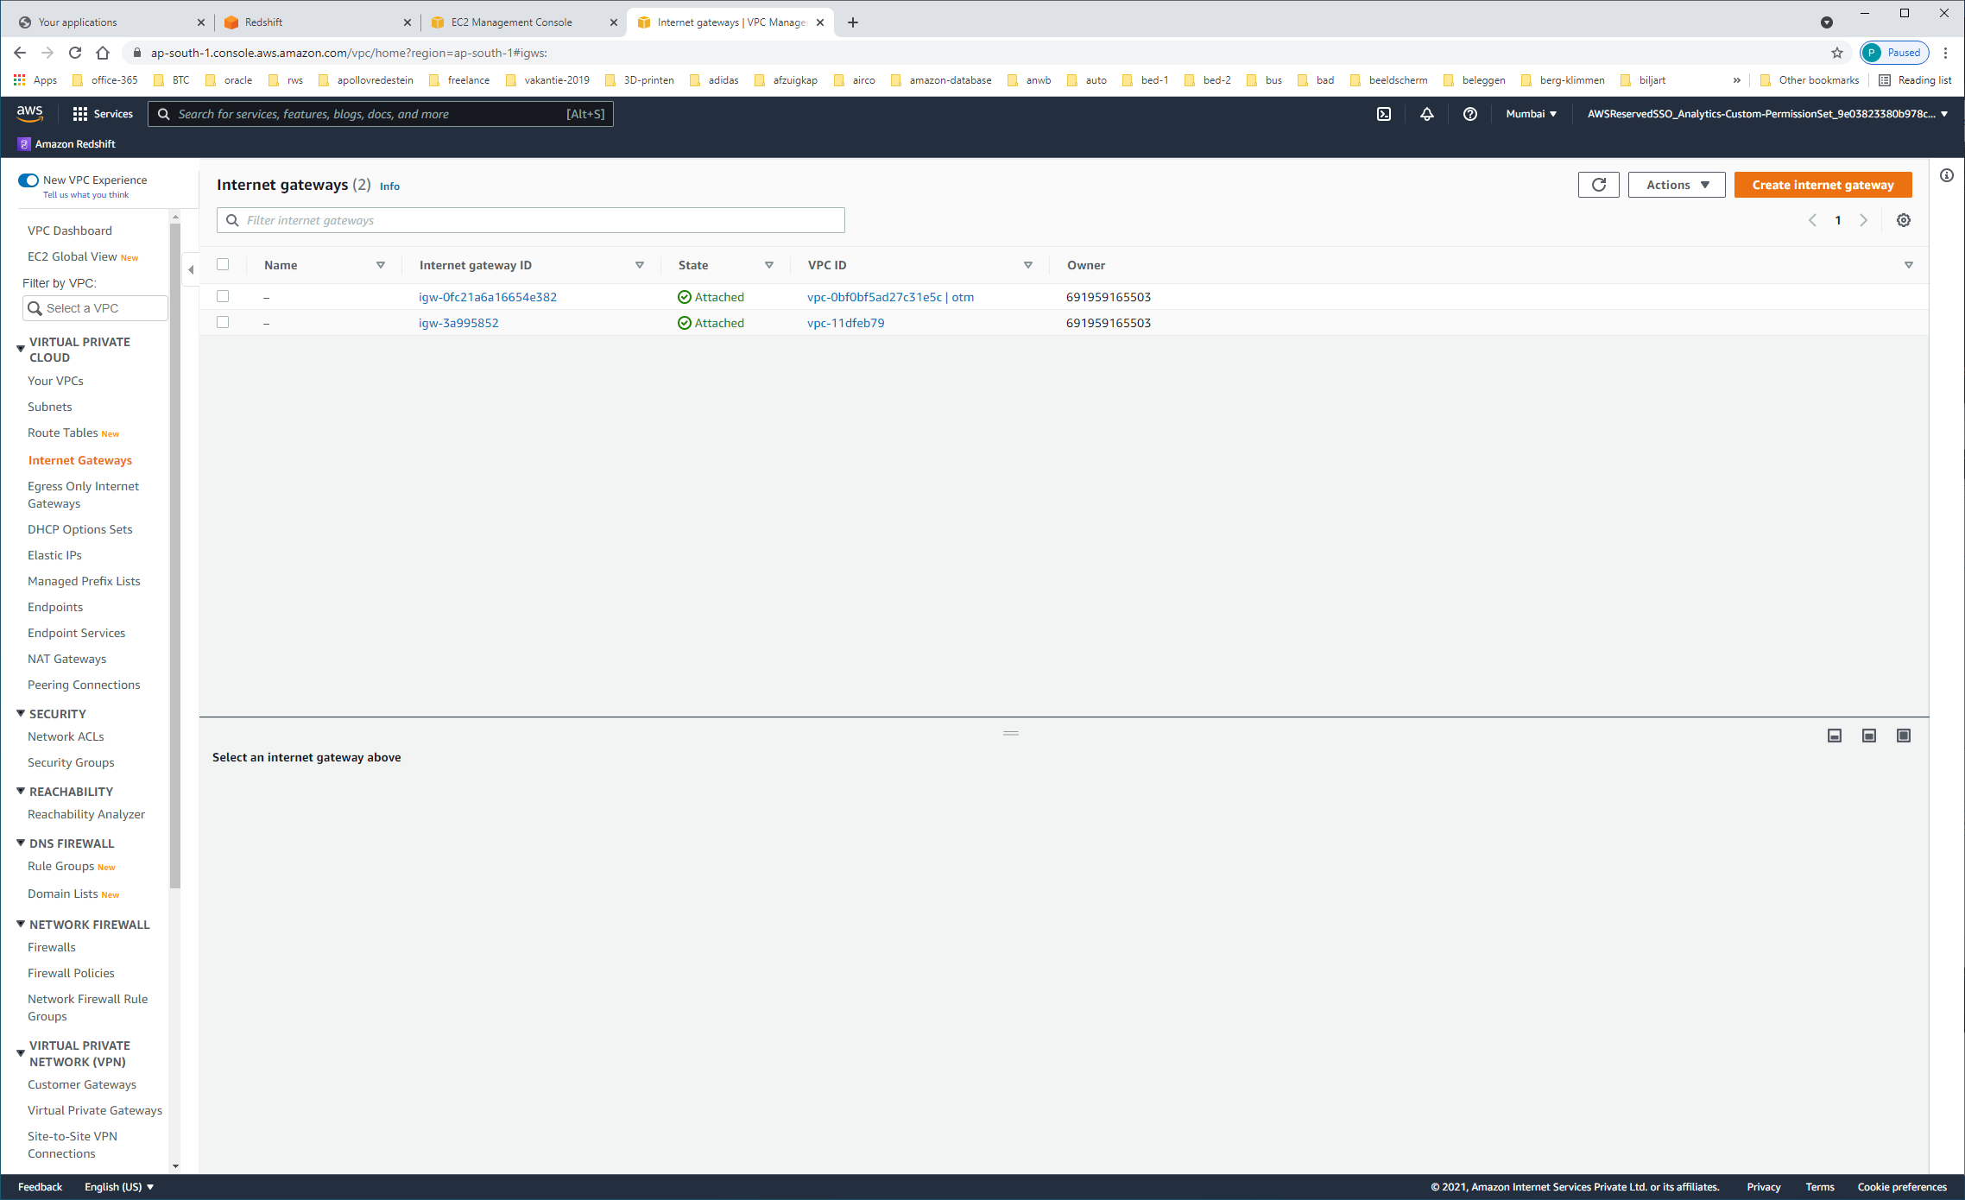

| **Internet gateway ID** | **State** | | | **VPC ID** | **Owner** | |
| --- | --- | --- | --- | --- | --- | --- |
| [igw-0fc21a6a16654e382](https://ap-south-1.console.aws.amazon.com/vpc/home?region=ap-south-1#InternetGateway:internetGatewayId=igw-0fc21a6a16654e382) | | Attached | [vpc-0bf0bf5ad27c31e5c | otm](https://ap-south-1.console.aws.amazon.com/vpc/home?region=ap-south-1#vpcs:VpcId=vpc-0bf0bf5ad27c31e5c) | | | 691959165503 | |
| [igw-3a995852](https://ap-south-1.console.aws.amazon.com/vpc/home?region=ap-south-1#InternetGateway:internetGatewayId=igw-3a995852) | | Attached | [vpc-11dfeb79](https://ap-south-1.console.aws.amazon.com/vpc/home?region=ap-south-1#vpcs:VpcId=vpc-11dfeb79) | | | 691959165503 | |

ELASTIC-IP's

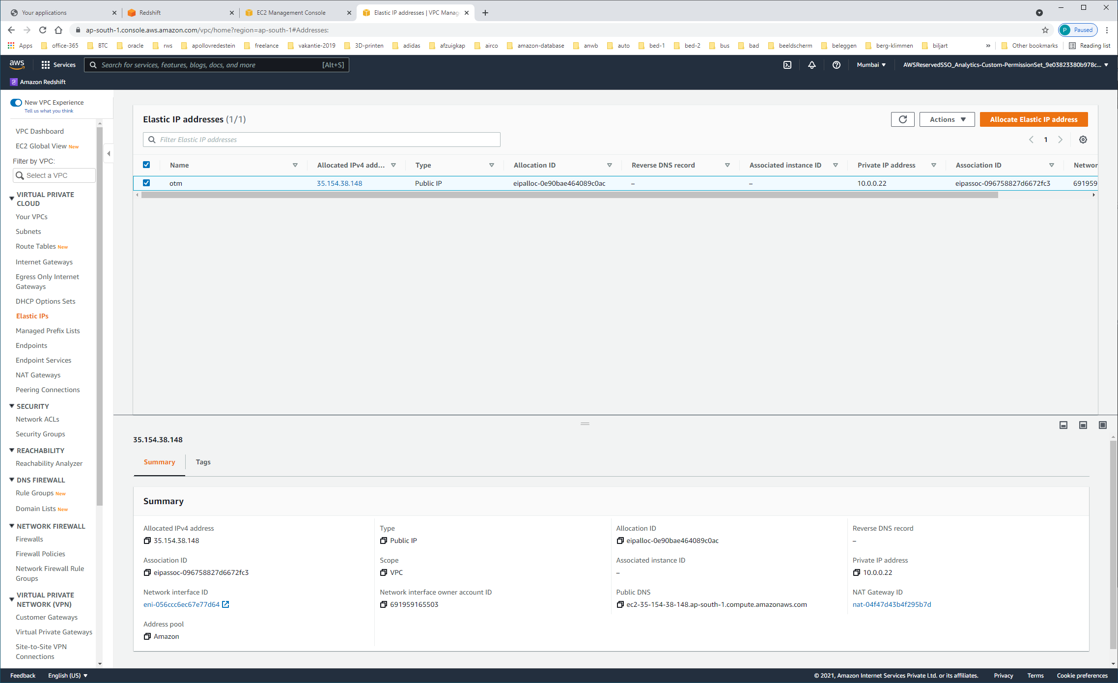

Allocated IPv4 address 35.154.38.148

Type Public IP

Allocation ID eipalloc-0e90bae464089c0ac

Reverse DNS record –

Association ID eipassoc-096758827d6672fc3

Scope VPC

Associated instance ID –

Private IP address 10.0.0.22

Network interface ID [eni-056ccc6ec67e77d64](https://ap-south-1.console.aws.amazon.com/ec2/v2/home#NIC:networkInterfaceId=eni-056ccc6ec67e77d64)

Network interface owner account ID 691959165503

Public DNS ec2-35-154-38-148.ap-south-1.compute.amazonaws.com

NAT Gateway ID [nat-04f47d43b4f295b7d](https://ap-south-1.console.aws.amazon.com/vpc/home#NatGateways:natGatewayId=nat-04f47d43b4f295b7d)

ENDPOINTS

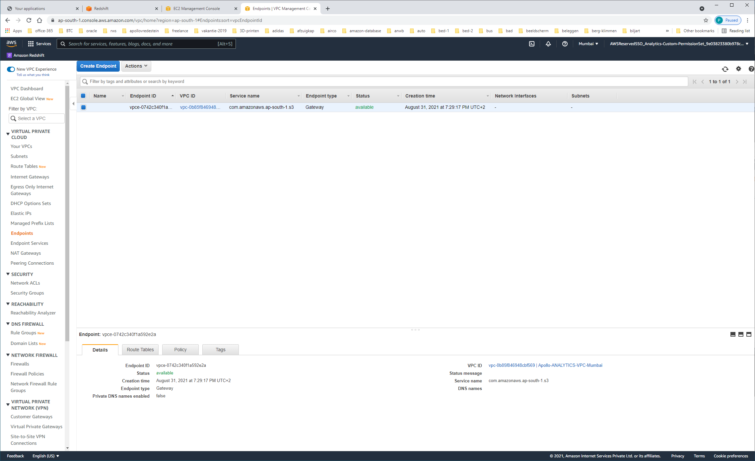

|  |  |
| --- | --- |
| **Endpoint ID**  vpce-0742c340f1a592e2a | **VPC ID**  [vpc-0b85f846948cbf569 | Apollo-ANALYTICS-VPC-Mumbai](https://ap-south-1.console.aws.amazon.com/vpc/home?region=ap-south-1#vpcs:filter=vpc-0b85f846948cbf569) |
| **Status**  available | **Status message** |
| **Creation time**  August 31, 2021 at 7:29:17 PM UTC+2 | **Service name**  com.amazonaws.ap-south-1.s3 |
| **Endpoint type**  Gateway |  |

NAT-GATEWAY

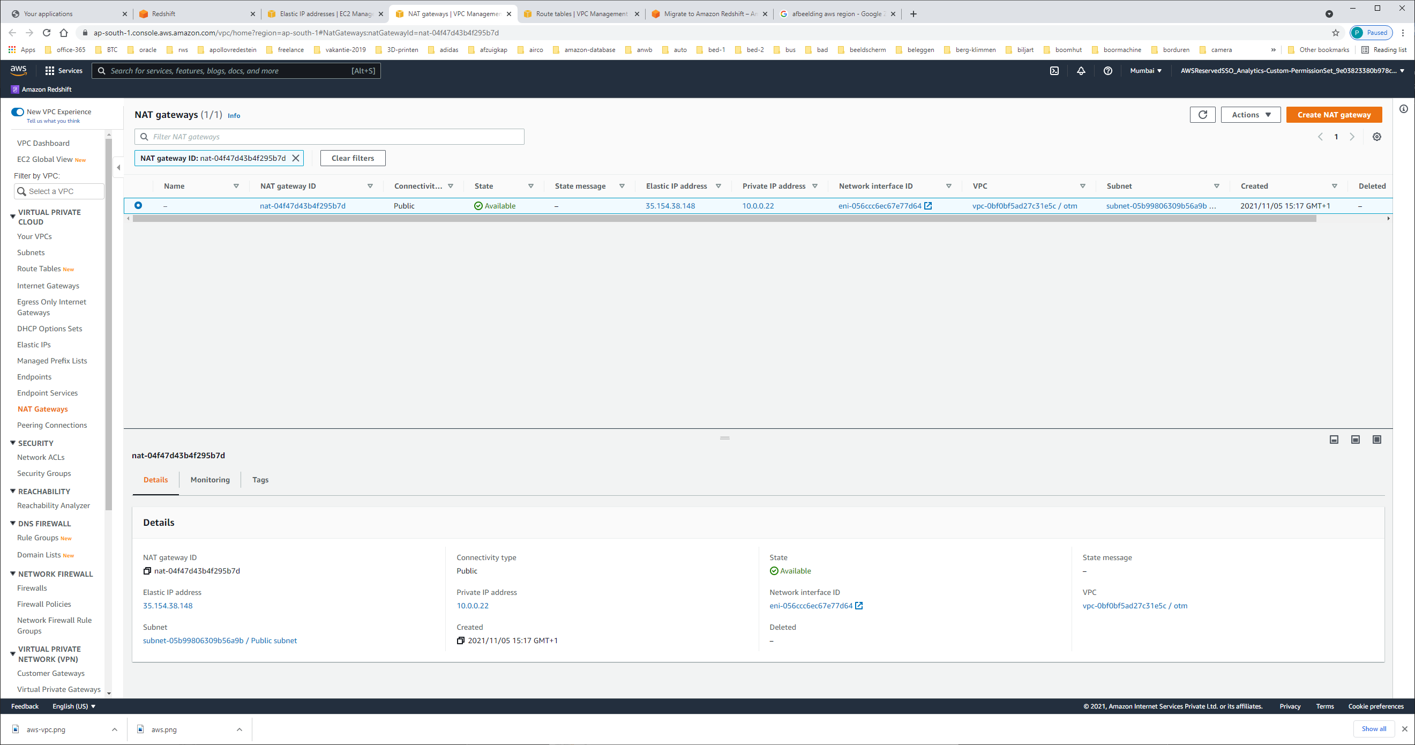

NAT gateway ID nat-04f47d43b4f295b7d

Elastic IP address [35.154.38.148](https://ap-south-1.console.aws.amazon.com/vpc/home?region=ap-south-1#Addresses:public-ip=35.154.38.148)

Subnet [subnet-05b99806309b56a9b / Public subnet](https://ap-south-1.console.aws.amazon.com/vpc/home?region=ap-south-1#subnets:SubnetId=subnet-05b99806309b56a9b)

Connectivity type Public

Private IP address [10.0.0.22](https://ap-south-1.console.aws.amazon.com/vpc/home?region=ap-south-1#Addresses:private-ip-address=10.0.0.22)

Network-Interface-ID [eni-056ccc6ec67e77d64](https://ap-south-1.console.aws.amazon.com/ec2/home?region=ap-south-1#NIC:networkInterfaceId=eni-056ccc6ec67e77d64)  
VPC [vpc-0bf0bf5ad27c31e5c / otm](https://ap-south-1.console.aws.amazon.com/vpc/home?region=ap-south-1#vpcs:VpcId=vpc-0bf0bf5ad27c31e5c)  
Subnet [subnet-05b99806309b56a9b / Public subnet](https://ap-south-1.console.aws.amazon.com/vpc/home?region=ap-south-1#subnets:SubnetId=subnet-05b99806309b56a9b)

REACHABILITY-ANALYZER

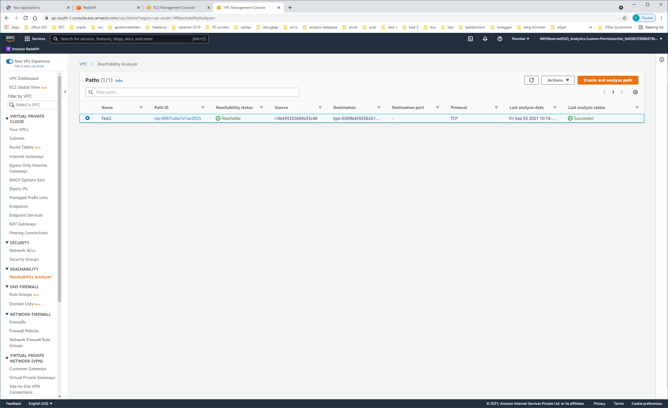

[nip-0997caba1d1ae2925](https://ap-south-1.console.aws.amazon.com/vpc/home?region=ap-south-1#NetworkPath:pathId=nip-0997caba1d1ae2925)

tgw-0309b459256261ebb

TRANSIT-GATEWAY

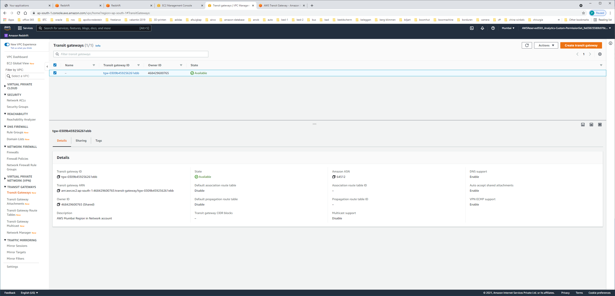

Transit gateway ID tgw-0309b459256261ebb

Transit gateway ARN arn:aws:ec2:ap-south-1:468429600765:transit-gateway/tgw-0309b459256261ebbOwner ID

468429600765 (Shared)

Description AWS Mumbai Region in Network account

Amazon ASN 64512

VPC-PEERING-CONNECTION

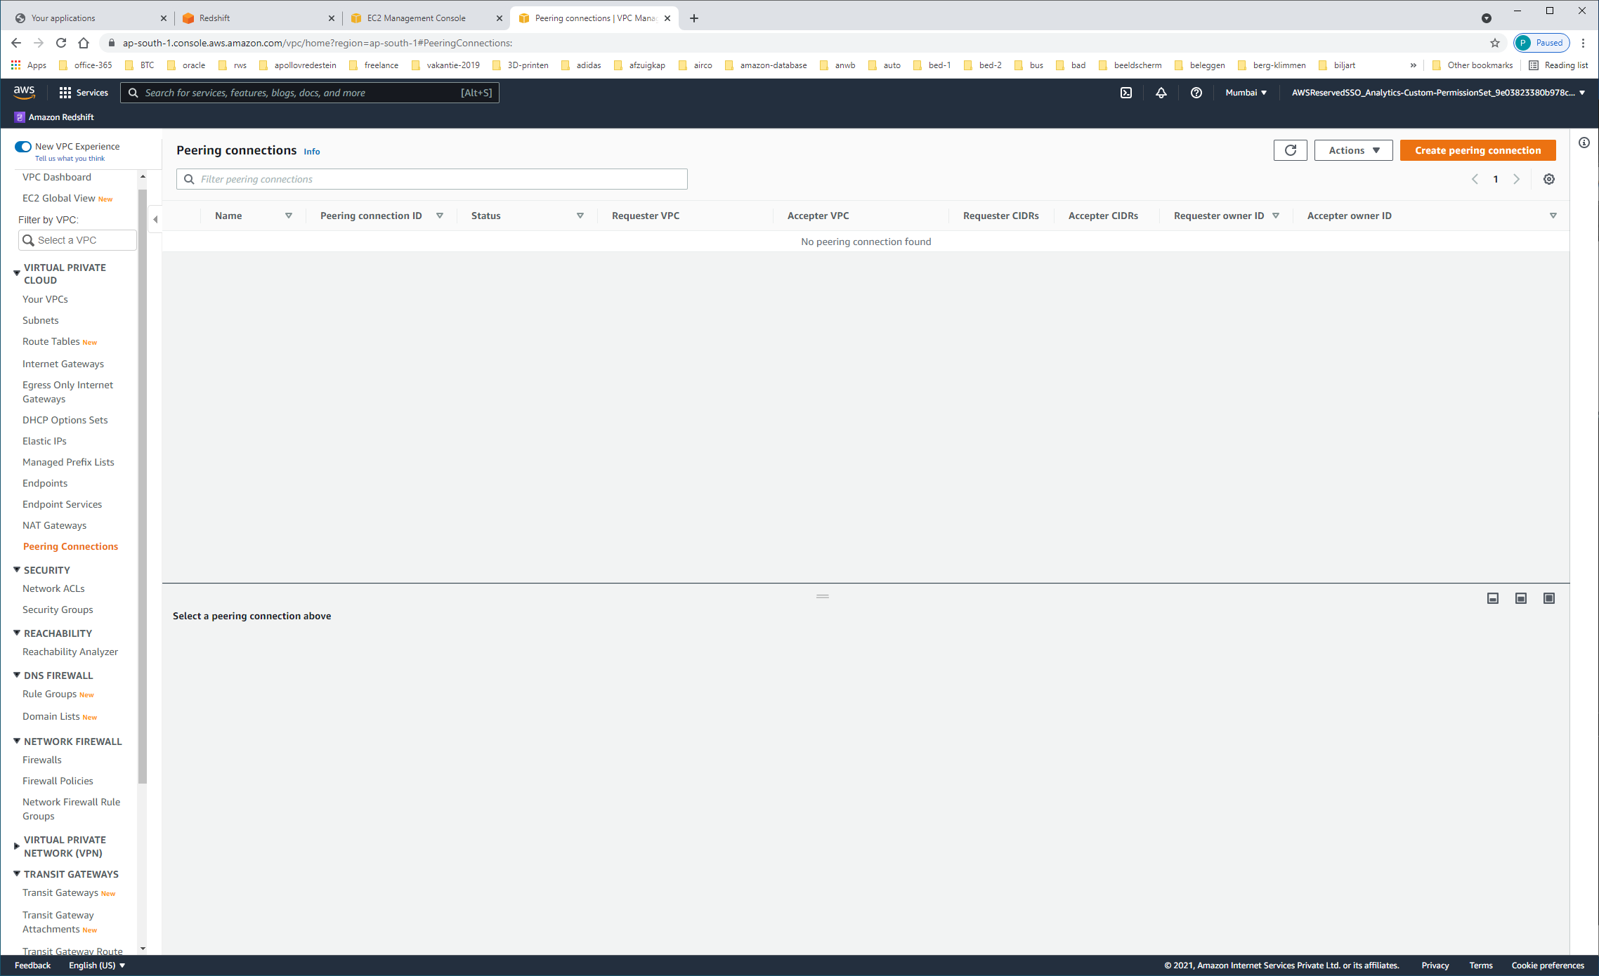

Geen VPC-peering

DHCP-OPTION-SETS

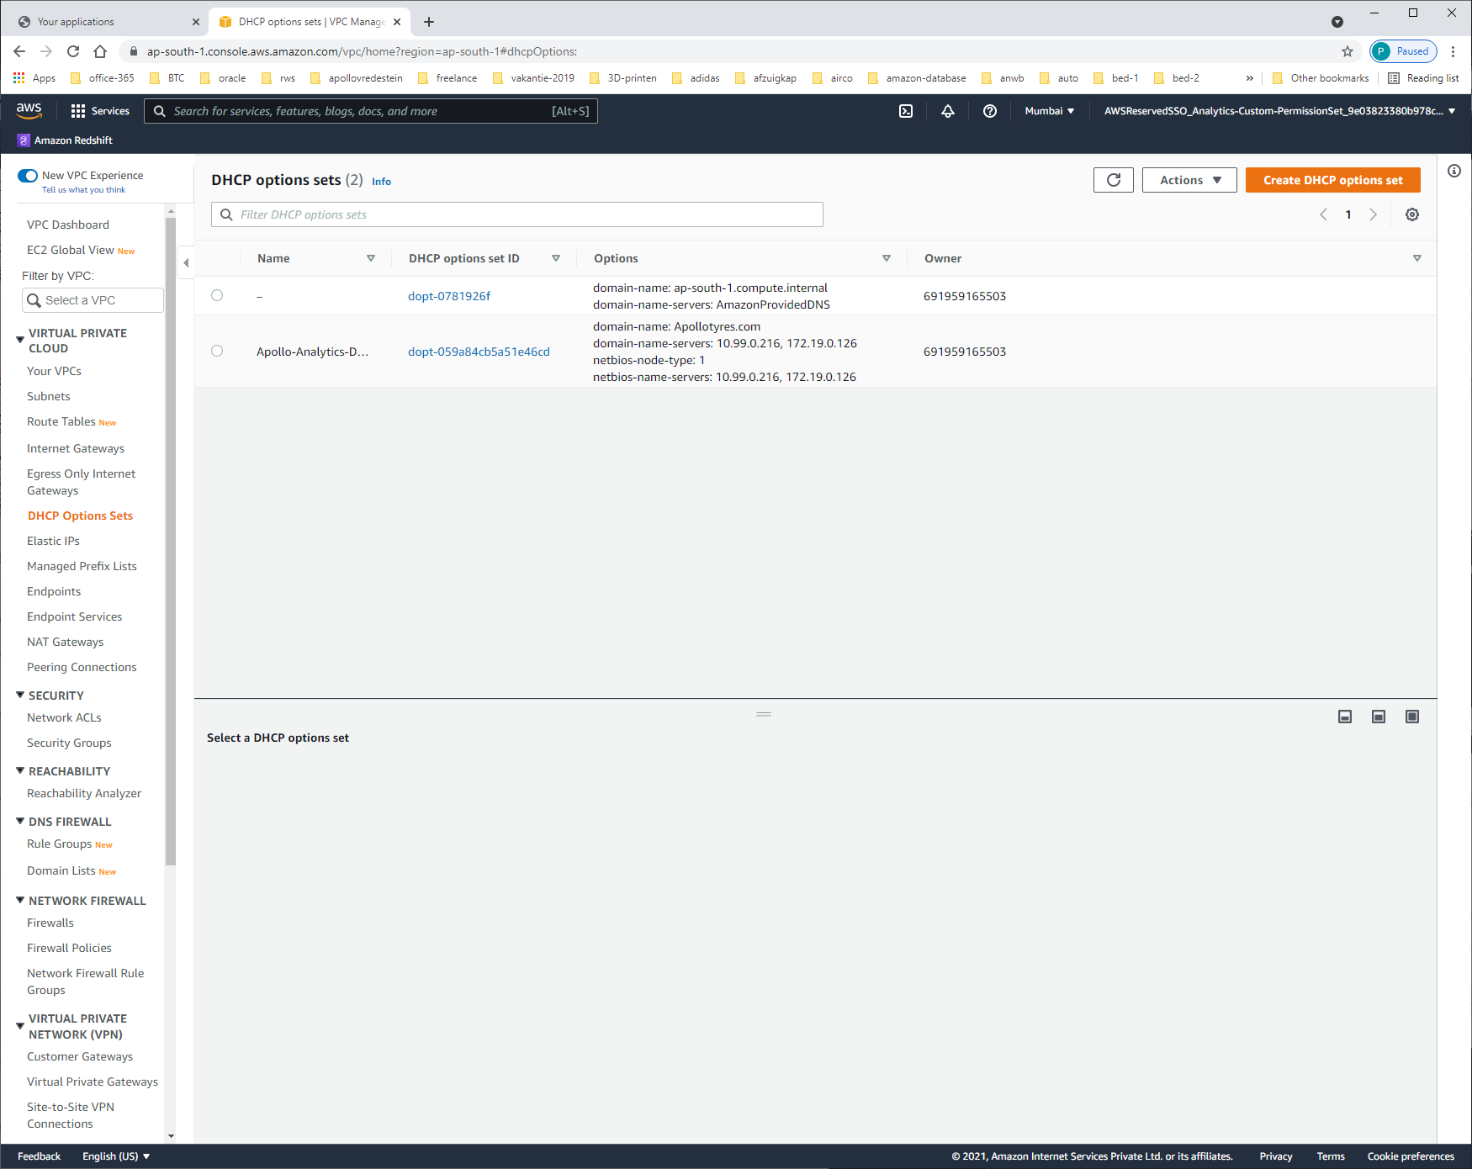

| **Name** | **DHCP options set ID** | **Options** | **Owner** |
| --- | --- | --- | --- |
|  | – | [dopt-0781926f](https://ap-south-1.console.aws.amazon.com/vpc/home?region=ap-south-1#DhcpOptionsDetails:DhcpOptionsId=dopt-0781926f) | domain-name: ap-south-1.compute.internal domain-name-servers: AmazonProvidedDNS | 691959165503 |
|  | Apollo-Analytics-DHCPSet01 | [dopt-059a84cb5a51e46cd](https://ap-south-1.console.aws.amazon.com/vpc/home?region=ap-south-1#DhcpOptionsDetails:DhcpOptionsId=dopt-059a84cb5a51e46cd) | domain-name: Apollotyres.com domain-name-servers: 10.99.0.216, 172.19.0.126 netbios-node-type: 1 netbios-name-servers: 10.99.0.216, 172.19.0.126 | 691959165503 |

MANAGED-PREFIX-LISTS

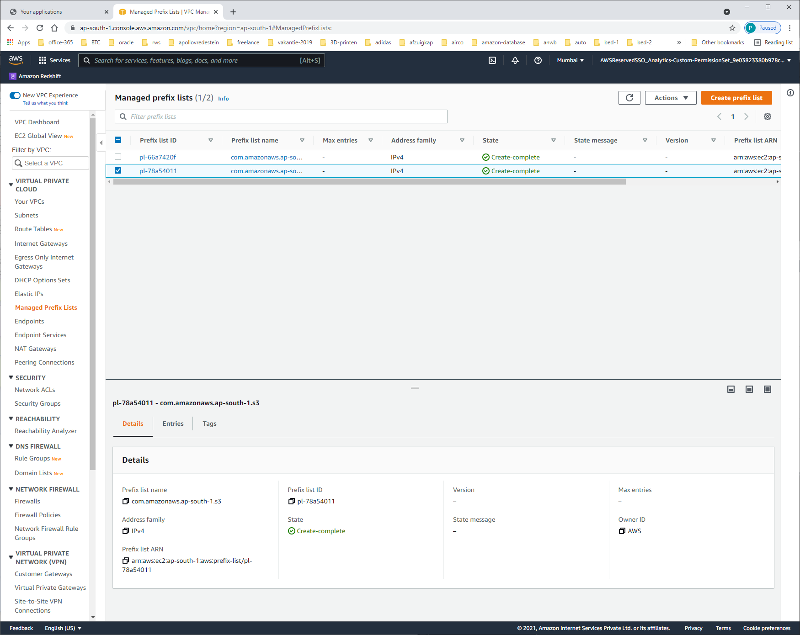

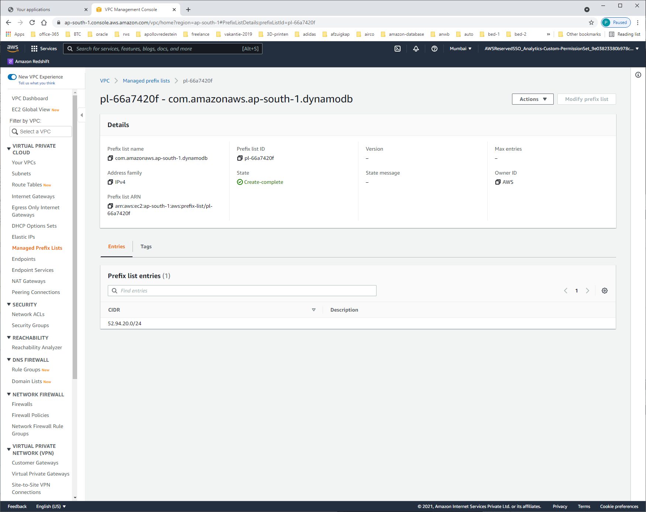

| **CIDR** | **Description** |
| --- | --- |
| 52.94.20.0/24 |  |

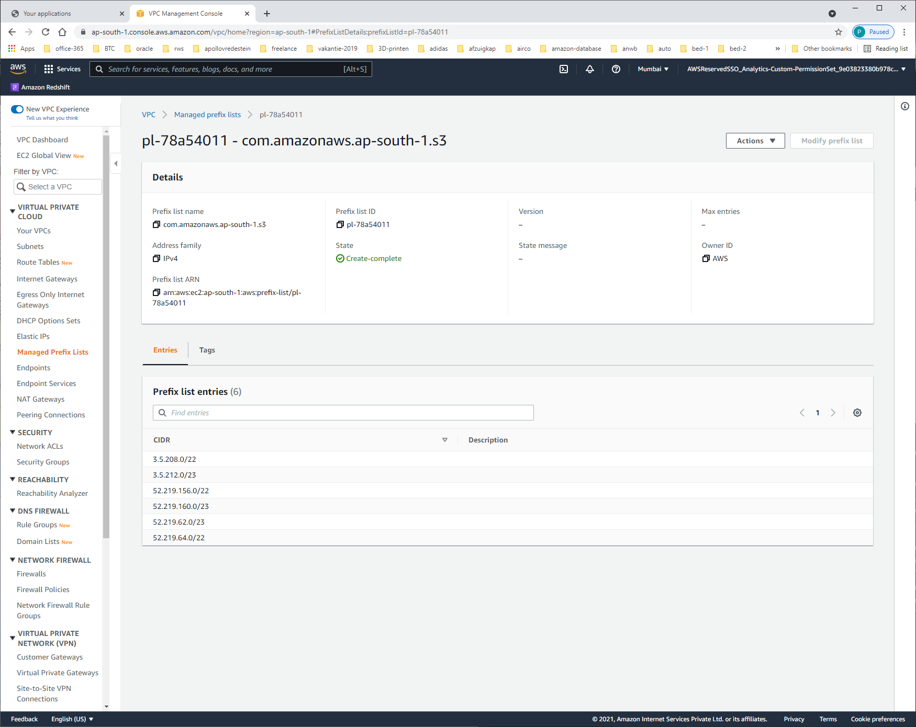

| **CIDR** | **Description** |
| --- | --- |
| 3.5.208.0/22 |  |
| 3.5.212.0/23 |  |
| 52.219.156.0/22 |  |
| 52.219.160.0/23 |  |
| 52.219.62.0/23 |  |
| 52.219.64.0/22 |  |

SETTINGS

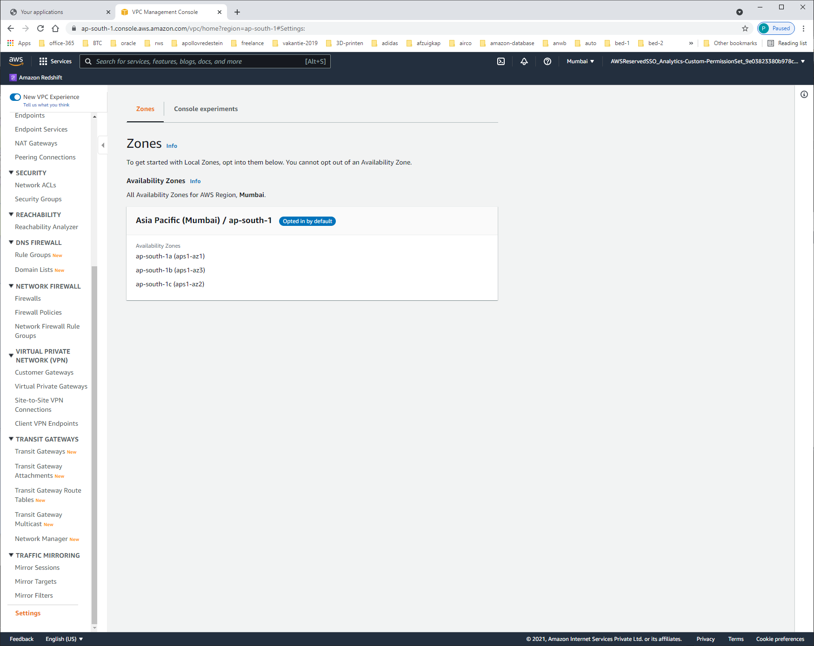

Availability Zones

ap-south-1a (aps1-az1)

ap-south-1b (aps1-az3)

ap-south-1c (aps1-az2)

NETWORK-ACLs

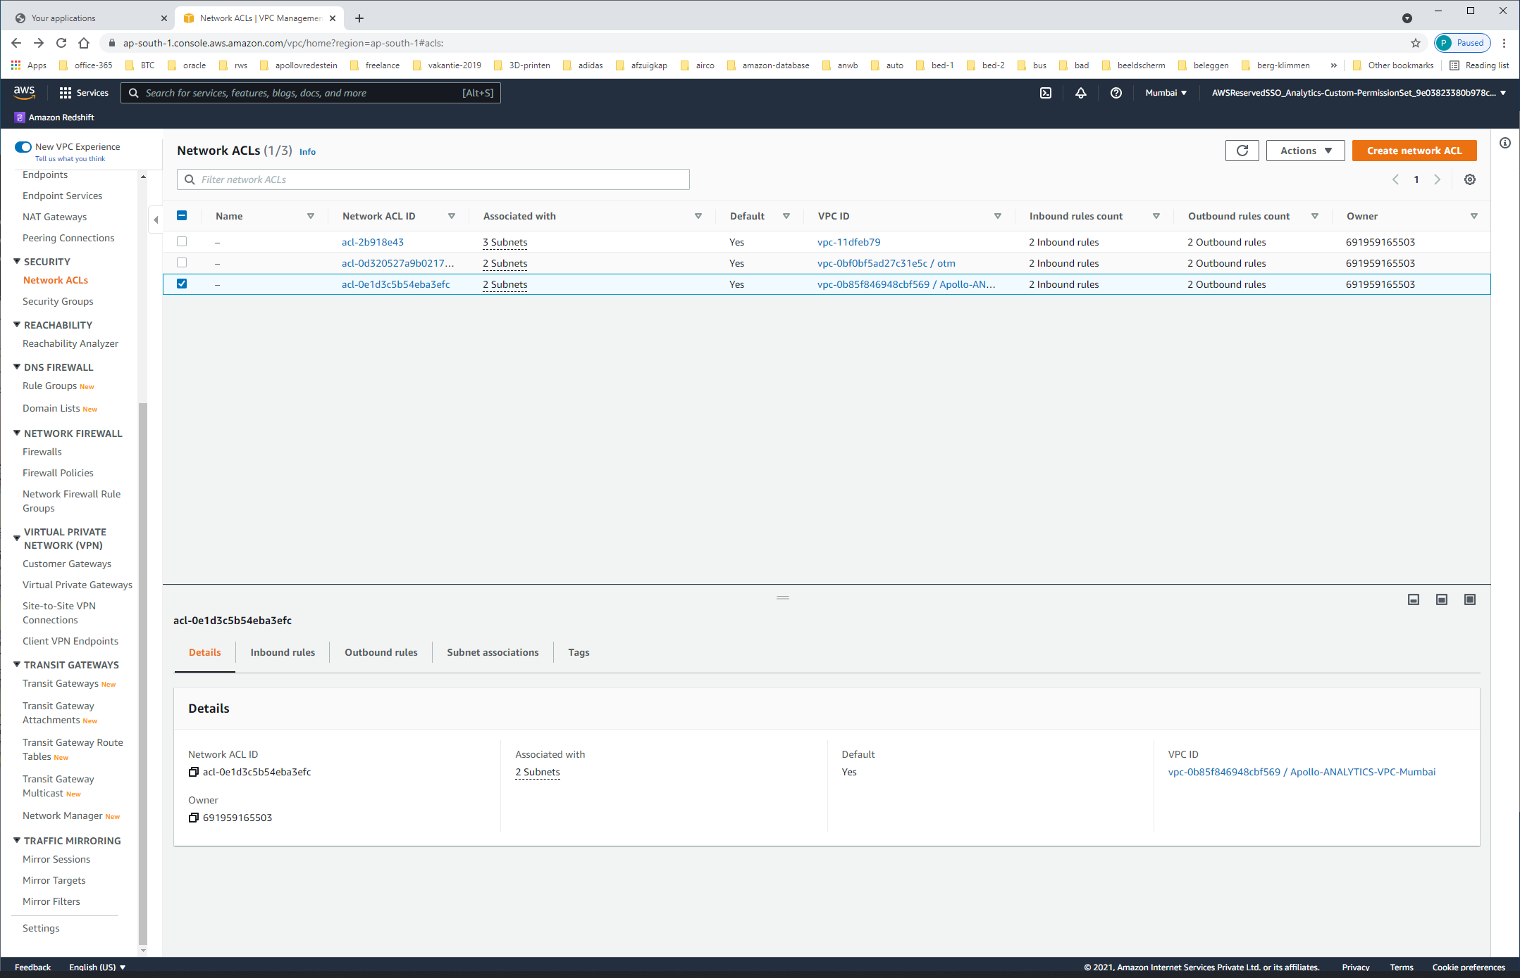

| **Network ACL ID** | **Associated with** | **Default** | **VPC ID** | **Inbound rules count** | **Outbound rules count** | **Owner** |
| --- | --- | --- | --- | --- | --- | --- |
|  | – | [acl-2b918e43](https://ap-south-1.console.aws.amazon.com/vpc/home?region=ap-south-1#NetworkAclDetails:networkAclId=acl-2b918e43) | 3 Subnets | Yes | [vpc-11dfeb79](https://ap-south-1.console.aws.amazon.com/vpc/home?region=ap-south-1#vpcs:VpcId=vpc-11dfeb79) | 2 Inbound rules | 2 Outbound rules | 691959165503 |
|  | – | [acl-0d320527a9b02175a](https://ap-south-1.console.aws.amazon.com/vpc/home?region=ap-south-1#NetworkAclDetails:networkAclId=acl-0d320527a9b02175a) | 2 Subnets | Yes | [vpc-0bf0bf5ad27c31e5c / otm](https://ap-south-1.console.aws.amazon.com/vpc/home?region=ap-south-1#vpcs:VpcId=vpc-0bf0bf5ad27c31e5c) | 2 Inbound rules | 2 Outbound rules | 691959165503 |
|  | – | [acl-0e1d3c5b54eba3efc](https://ap-south-1.console.aws.amazon.com/vpc/home?region=ap-south-1#NetworkAclDetails:networkAclId=acl-0e1d3c5b54eba3efc) | 2 Subnets | Yes | [vpc-0b85f846948cbf569 / Apollo-ANALYTICS-VPC-Mumbai](https://ap-south-1.console.aws.amazon.com/vpc/home?region=ap-south-1#vpcs:VpcId=vpc-0b85f846948cbf569) | 2 Inbound rules | 2 Outbound rules | 691959165503 |

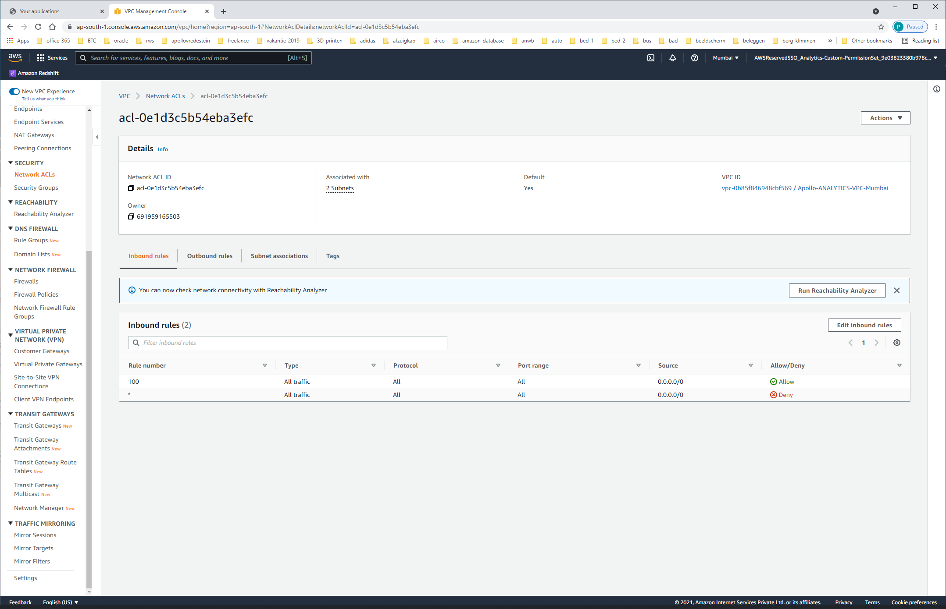

Outbound-rules gelijk aan Inbound-rules

Subnets:

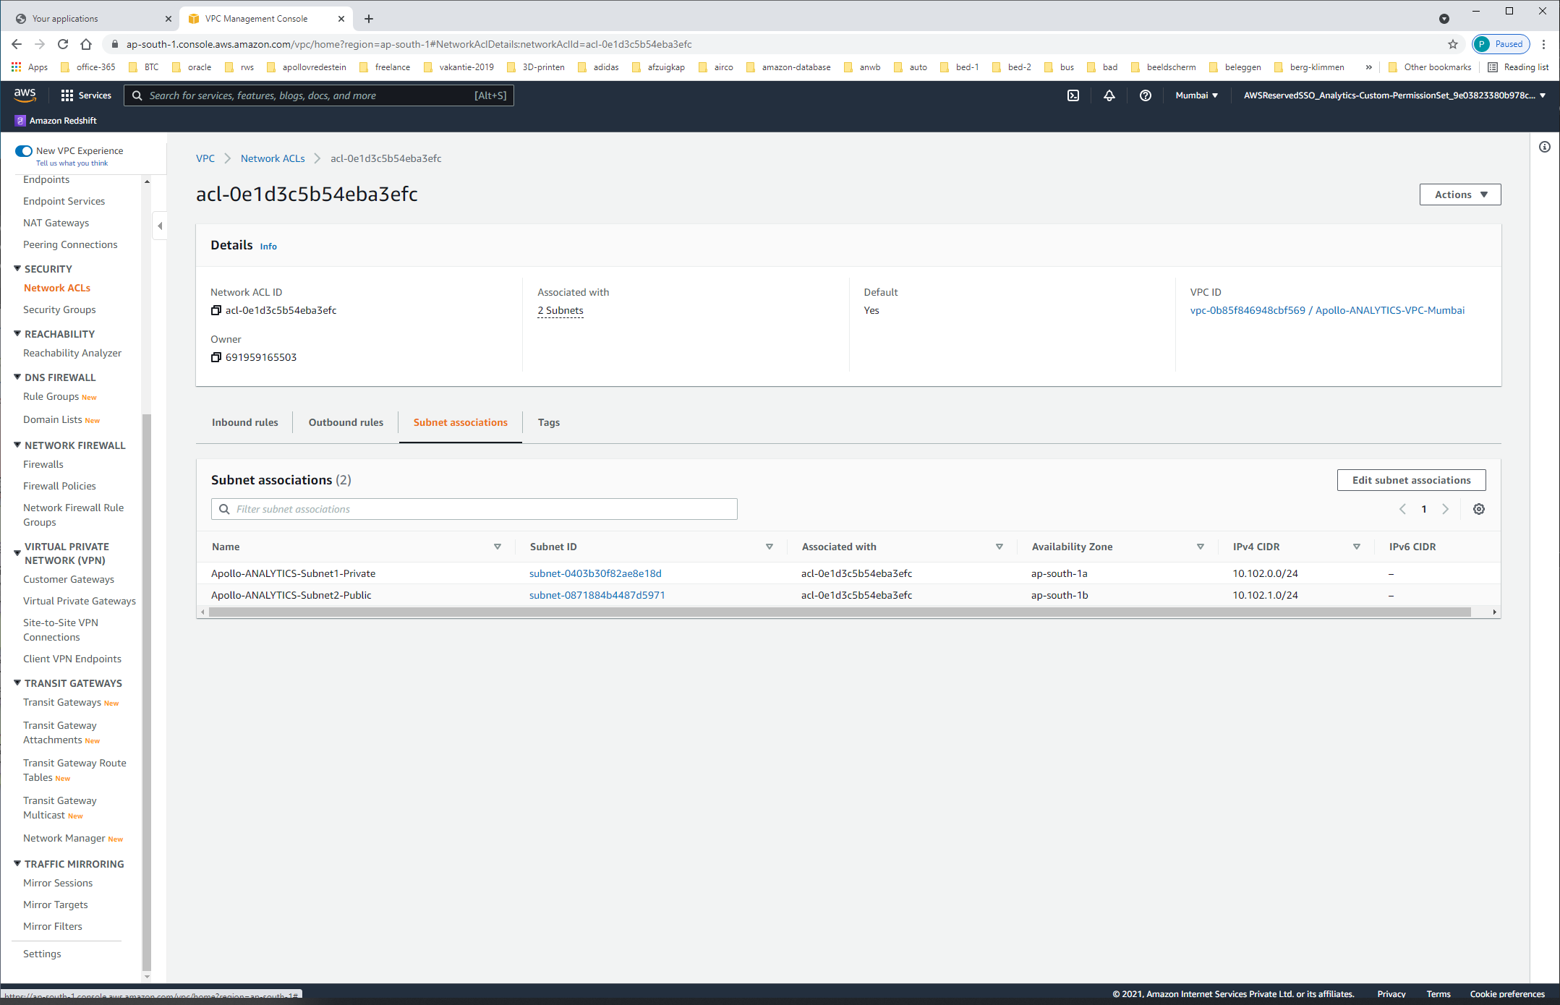

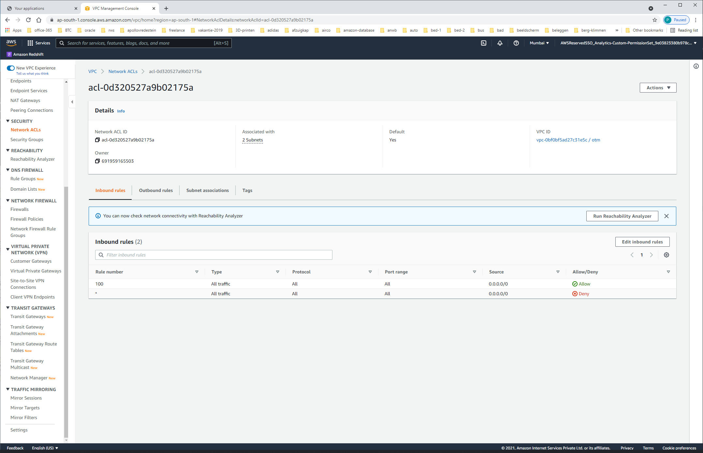

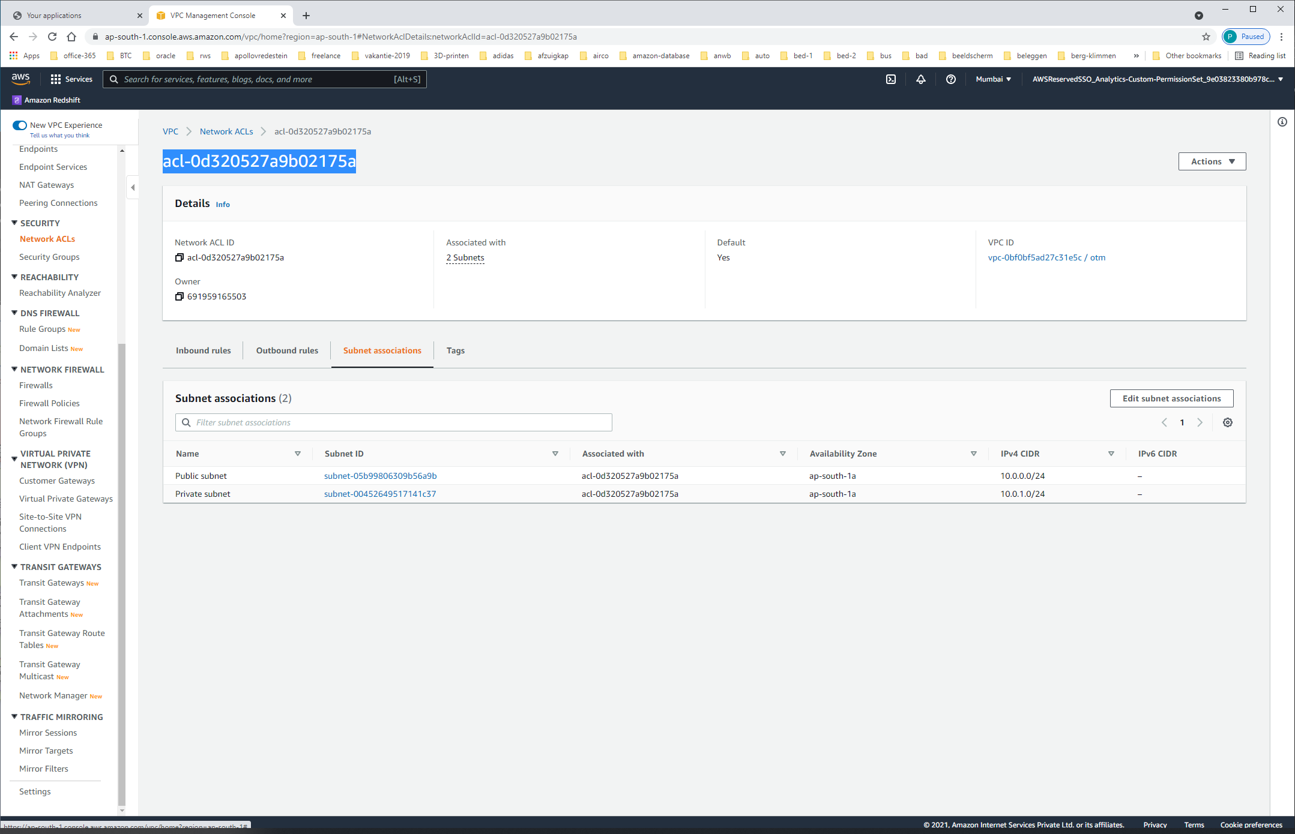

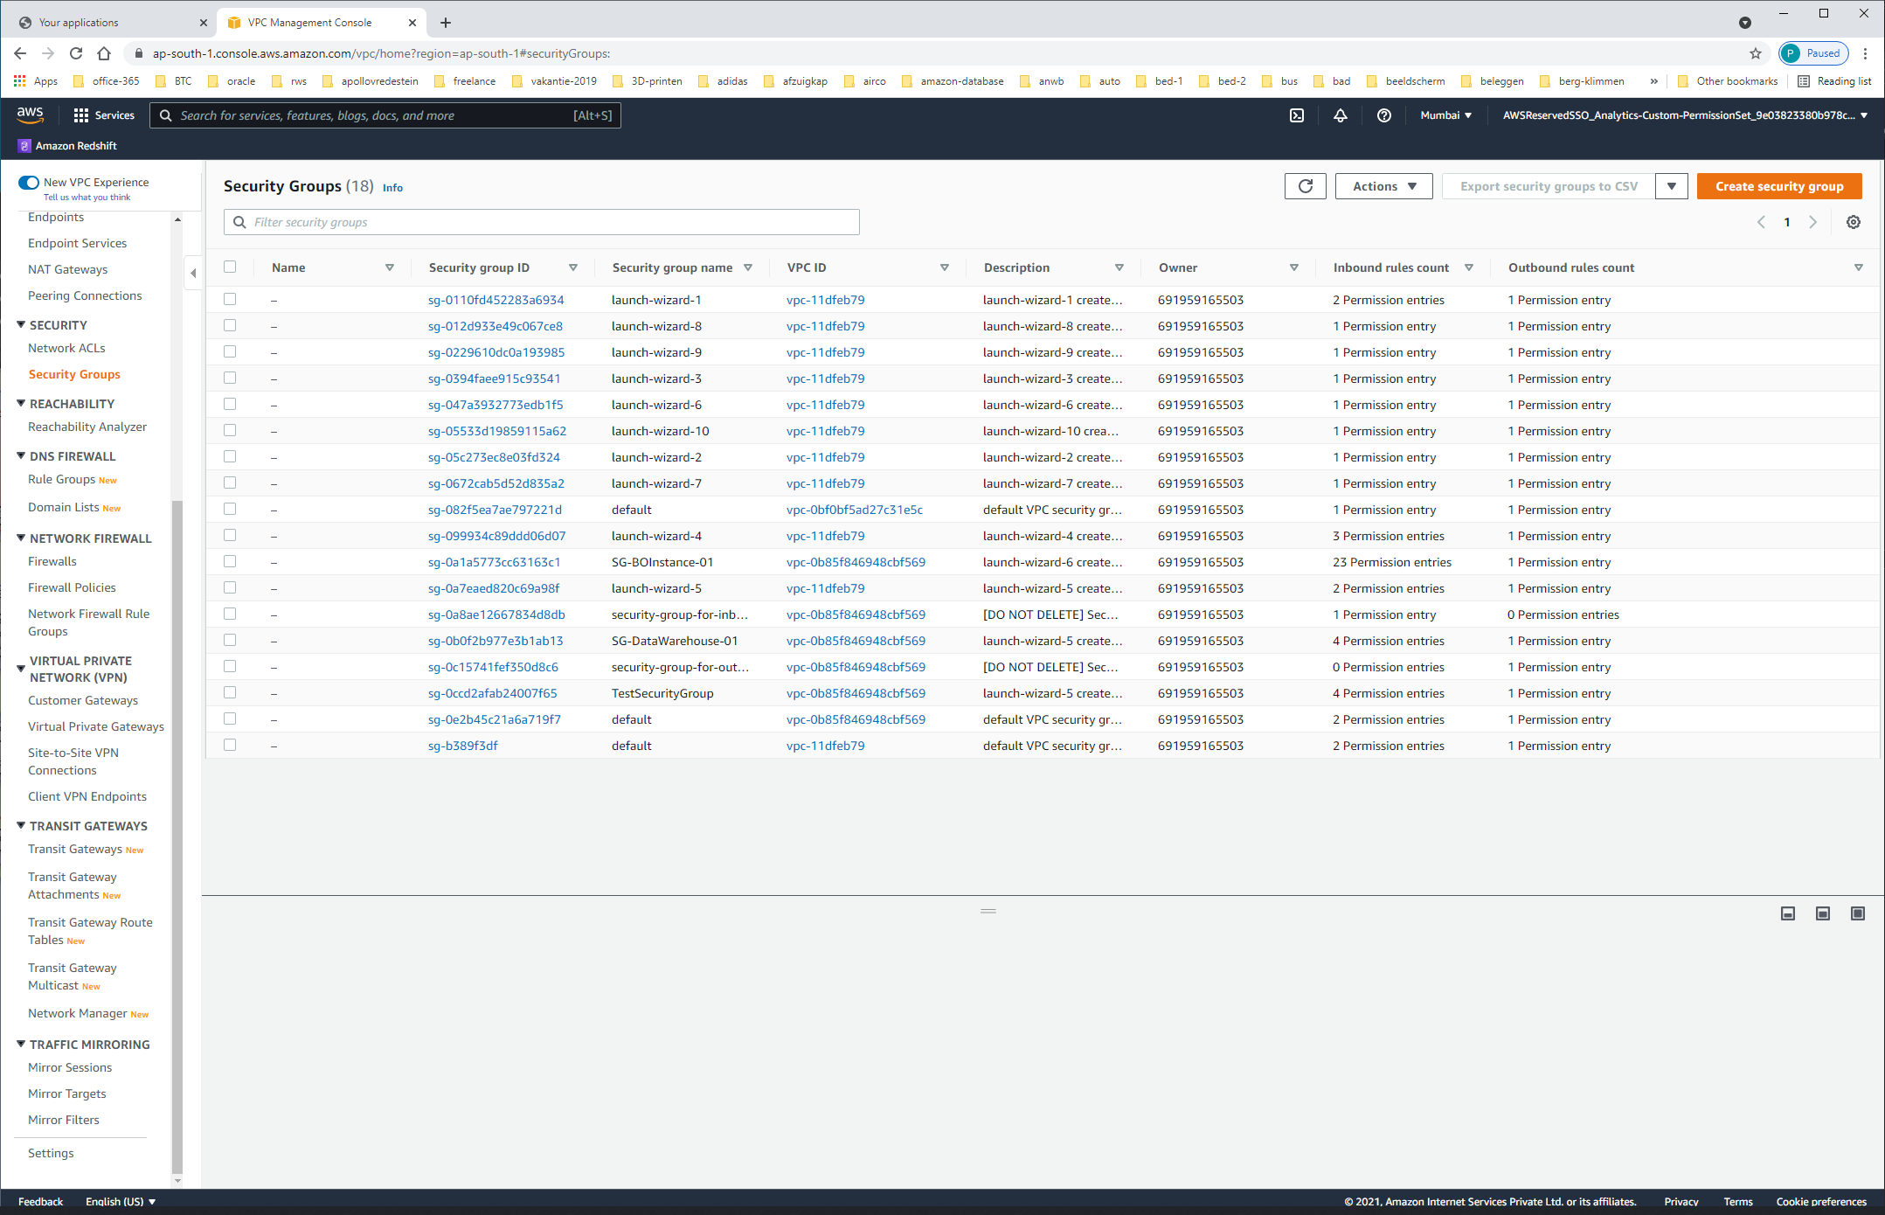

| **Name** | **Security group ID** | **Security group name** | **VPC ID** | **Description** | **Owner** | **Inbound rules count** | **Outbound rules count** |
| --- | --- | --- | --- | --- | --- | --- | --- |
|  | – | [sg-0110fd452283a6934](https://ap-south-1.console.aws.amazon.com/vpc/home?region=ap-south-1#SecurityGroup:groupId=sg-0110fd452283a6934) | launch-wizard-1 | [vpc-11dfeb79](https://ap-south-1.console.aws.amazon.com/vpc/home?region=ap-south-1#vpcs:VpcId=vpc-11dfeb79) | launch-wizard-1 created 2021-05-20T00:26:00.896+05:30 | 691959165503 | 2 Permission entries | 1 Permission entry |
|  | – | [sg-012d933e49c067ce8](https://ap-south-1.console.aws.amazon.com/vpc/home?region=ap-south-1#SecurityGroup:groupId=sg-012d933e49c067ce8) | launch-wizard-8 | [vpc-11dfeb79](https://ap-south-1.console.aws.amazon.com/vpc/home?region=ap-south-1#vpcs:VpcId=vpc-11dfeb79) | launch-wizard-8 created 2021-11-17T16:22:45.446+05:30 | 691959165503 | 1 Permission entry | 1 Permission entry |
|  | – | [sg-0229610dc0a193985](https://ap-south-1.console.aws.amazon.com/vpc/home?region=ap-south-1#SecurityGroup:groupId=sg-0229610dc0a193985) | launch-wizard-9 | [vpc-11dfeb79](https://ap-south-1.console.aws.amazon.com/vpc/home?region=ap-south-1#vpcs:VpcId=vpc-11dfeb79) | launch-wizard-9 created 2021-11-17T16:37:52.454+05:30 | 691959165503 | 1 Permission entry | 1 Permission entry |
|  | – | [sg-0394faee915c93541](https://ap-south-1.console.aws.amazon.com/vpc/home?region=ap-south-1#SecurityGroup:groupId=sg-0394faee915c93541) | launch-wizard-3 | [vpc-11dfeb79](https://ap-south-1.console.aws.amazon.com/vpc/home?region=ap-south-1#vpcs:VpcId=vpc-11dfeb79) | launch-wizard-3 created 2021-05-20T02:05:38.122+05:30 | 691959165503 | 1 Permission entry | 1 Permission entry |
|  | – | [sg-047a3932773edb1f5](https://ap-south-1.console.aws.amazon.com/vpc/home?region=ap-south-1#SecurityGroup:groupId=sg-047a3932773edb1f5) | launch-wizard-6 | [vpc-11dfeb79](https://ap-south-1.console.aws.amazon.com/vpc/home?region=ap-south-1#vpcs:VpcId=vpc-11dfeb79) | launch-wizard-6 created 2021-11-03T10:53:17.097+05:30 | 691959165503 | 1 Permission entry | 1 Permission entry |
|  | – | [sg-05533d19859115a62](https://ap-south-1.console.aws.amazon.com/vpc/home?region=ap-south-1#SecurityGroup:groupId=sg-05533d19859115a62) | launch-wizard-10 | [vpc-11dfeb79](https://ap-south-1.console.aws.amazon.com/vpc/home?region=ap-south-1#vpcs:VpcId=vpc-11dfeb79) | launch-wizard-10 created 2021-11-19T12:36:50.763+05:30 | 691959165503 | 1 Permission entry | 1 Permission entry |
|  | – | [sg-05c273ec8e03fd324](https://ap-south-1.console.aws.amazon.com/vpc/home?region=ap-south-1#SecurityGroup:groupId=sg-05c273ec8e03fd324) | launch-wizard-2 | [vpc-11dfeb79](https://ap-south-1.console.aws.amazon.com/vpc/home?region=ap-south-1#vpcs:VpcId=vpc-11dfeb79) | launch-wizard-2 created 2021-05-20T00:38:55.415+05:30 | 691959165503 | 1 Permission entry | 1 Permission entry |
|  | – | [sg-0672cab5d52d835a2](https://ap-south-1.console.aws.amazon.com/vpc/home?region=ap-south-1#SecurityGroup:groupId=sg-0672cab5d52d835a2) | launch-wizard-7 | [vpc-11dfeb79](https://ap-south-1.console.aws.amazon.com/vpc/home?region=ap-south-1#vpcs:VpcId=vpc-11dfeb79) | launch-wizard-7 created 2021-11-11T17:21:31.413+05:30 | 691959165503 | 1 Permission entry | 1 Permission entry |
|  | – | [sg-082f5ea7ae797221d](https://ap-south-1.console.aws.amazon.com/vpc/home?region=ap-south-1#SecurityGroup:groupId=sg-082f5ea7ae797221d) | default | [vpc-0bf0bf5ad27c31e5c](https://ap-south-1.console.aws.amazon.com/vpc/home?region=ap-south-1#vpcs:VpcId=vpc-0bf0bf5ad27c31e5c) | default VPC security group | 691959165503 | 1 Permission entry | 1 Permission entry |
|  | – | [sg-099934c89ddd06d07](https://ap-south-1.console.aws.amazon.com/vpc/home?region=ap-south-1#SecurityGroup:groupId=sg-099934c89ddd06d07) | launch-wizard-4 | [vpc-11dfeb79](https://ap-south-1.console.aws.amazon.com/vpc/home?region=ap-south-1#vpcs:VpcId=vpc-11dfeb79) | launch-wizard-4 created 2021-06-25T13:40:44.687+05:30 | 691959165503 | 3 Permission entries | 1 Permission entry |
|  | – | [sg-0a1a5773cc63163c1](https://ap-south-1.console.aws.amazon.com/vpc/home?region=ap-south-1#SecurityGroup:groupId=sg-0a1a5773cc63163c1) | SG-BOInstance-01 | [vpc-0b85f846948cbf569](https://ap-south-1.console.aws.amazon.com/vpc/home?region=ap-south-1#vpcs:VpcId=vpc-0b85f846948cbf569) | launch-wizard-6 created 2021-11-01T14:44:34.009+05:30 | 691959165503 | 23 Permission entries | 1 Permission entry |
|  | – | [sg-0a7eaed820c69a98f](https://ap-south-1.console.aws.amazon.com/vpc/home?region=ap-south-1#SecurityGroup:groupId=sg-0a7eaed820c69a98f) | launch-wizard-5 | [vpc-11dfeb79](https://ap-south-1.console.aws.amazon.com/vpc/home?region=ap-south-1#vpcs:VpcId=vpc-11dfeb79) | launch-wizard-5 created 2021-10-28T15:19:57.673+05:30 | 691959165503 | 2 Permission entries | 1 Permission entry |
|  | – | [sg-0a8ae12667834d8db](https://ap-south-1.console.aws.amazon.com/vpc/home?region=ap-south-1#SecurityGroup:groupId=sg-0a8ae12667834d8db) | security-group-for-inbound-nfs-d-bxflhfwbyaqr | [vpc-0b85f846948cbf569](https://ap-south-1.console.aws.amazon.com/vpc/home?region=ap-south-1#vpcs:VpcId=vpc-0b85f846948cbf569) | [DO NOT DELETE] Security Group that allows inbound NFS traffic for SageMaker Notebooks Domain [d-bxflhfwbyaqr] | 691959165503 | 1 Permission entry | 0 Permission entries |
|  | – | [sg-0b0f2b977e3b1ab13](https://ap-south-1.console.aws.amazon.com/vpc/home?region=ap-south-1#SecurityGroup:groupId=sg-0b0f2b977e3b1ab13) | SG-DataWarehouse-01 | [vpc-0b85f846948cbf569](https://ap-south-1.console.aws.amazon.com/vpc/home?region=ap-south-1#vpcs:VpcId=vpc-0b85f846948cbf569) | launch-wizard-5 created 2021-10-05T12:50:15.792+05:30 | 691959165503 | 4 Permission entries | 1 Permission entry |
|  | – | [sg-0c15741fef350d8c6](https://ap-south-1.console.aws.amazon.com/vpc/home?region=ap-south-1#SecurityGroup:groupId=sg-0c15741fef350d8c6) | security-group-for-outbound-nfs-d-bxflhfwbyaqr | [vpc-0b85f846948cbf569](https://ap-south-1.console.aws.amazon.com/vpc/home?region=ap-south-1#vpcs:VpcId=vpc-0b85f846948cbf569) | [DO NOT DELETE] Security Group that allows outbound NFS traffic for SageMaker Notebooks Domain [d-bxflhfwbyaqr] | 691959165503 | 0 Permission entries | 1 Permission entry |
|  | – | [sg-0ccd2afab24007f65](https://ap-south-1.console.aws.amazon.com/vpc/home?region=ap-south-1#SecurityGroup:groupId=sg-0ccd2afab24007f65) | TestSecurityGroup | [vpc-0b85f846948cbf569](https://ap-south-1.console.aws.amazon.com/vpc/home?region=ap-south-1#vpcs:VpcId=vpc-0b85f846948cbf569) | launch-wizard-5 created 2021-08-23T15:17:57.395+05:30 | 691959165503 | 4 Permission entries | 1 Permission entry |
|  | – | [sg-0e2b45c21a6a719f7](https://ap-south-1.console.aws.amazon.com/vpc/home?region=ap-south-1#SecurityGroup:groupId=sg-0e2b45c21a6a719f7) | default | [vpc-0b85f846948cbf569](https://ap-south-1.console.aws.amazon.com/vpc/home?region=ap-south-1#vpcs:VpcId=vpc-0b85f846948cbf569) | default VPC security group | 691959165503 | 2 Permission entries | 1 Permission entry |
|  | – | [sg-b389f3df](https://ap-south-1.console.aws.amazon.com/vpc/home?region=ap-south-1#SecurityGroup:groupId=sg-b389f3df) | default | [vpc-11dfeb79](https://ap-south-1.console.aws.amazon.com/vpc/home?region=ap-south-1#vpcs:VpcId=vpc-11dfeb79) | default VPC security group | 691959165503 | 2 Permission entries | 1 Permission entry |

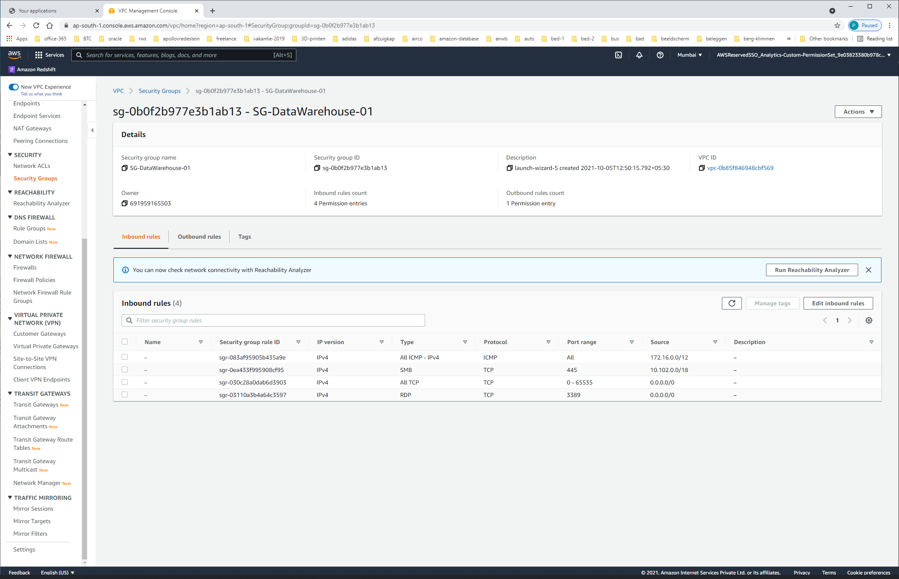

| **Name** | **Security group rule ID** | **IP version** | **Type** | **Protocol** | **Port range** | **Source** | **Description** |
| --- | --- | --- | --- | --- | --- | --- | --- |
|  | – | sgr-083af95905b435a9e | IPv4 | All ICMP - IPv4 | ICMP | All | 172.16.0.0/12 | – |
|  | – | sgr-0ea433f995908cf95 | IPv4 | SMB | TCP | 445 | 10.102.0.0/18 | – |
|  | – | sgr-030c28a0dab6d3903 | IPv4 | All TCP | TCP | 0 - 65535 | 0.0.0.0/0 | – |
|  | – | sgr-03110a3b4a64c3597 | IPv4 | RDP | TCP | 3389 | 0.0.0.0/0 | – |

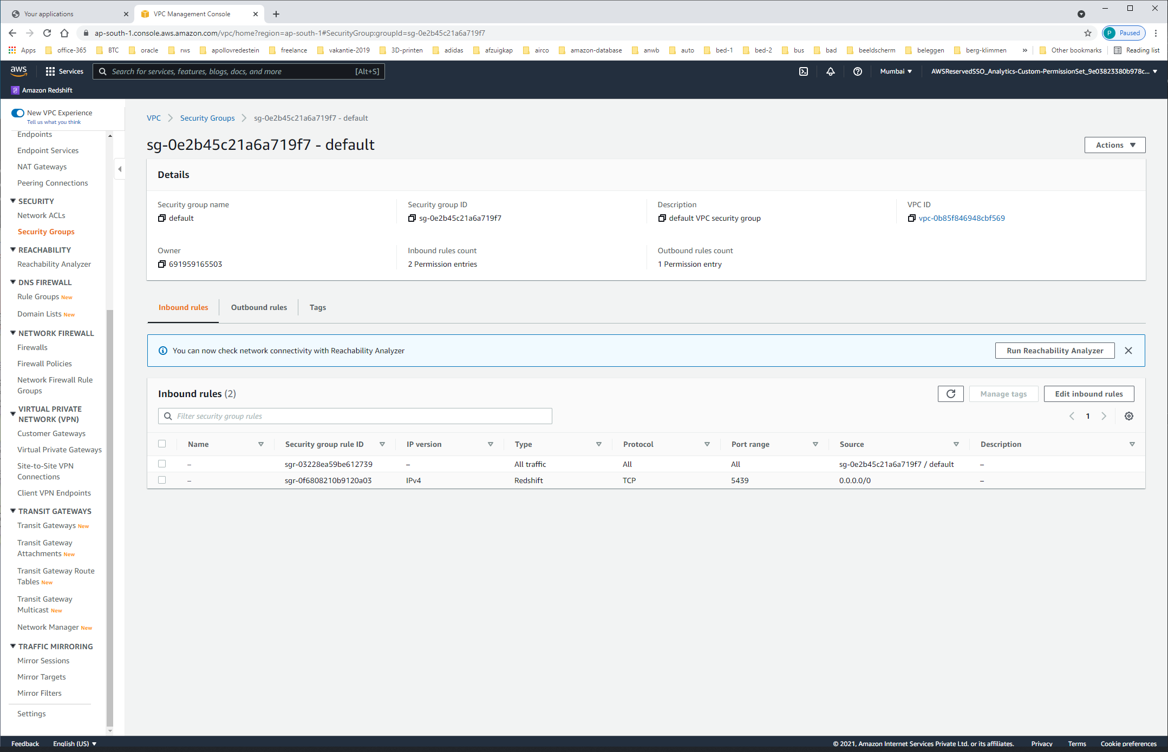

| **Name** | **Security group rule ID** | **IP version** | **Type** | **Protocol** | **Port range** | **Source** | **Description** |
| --- | --- | --- | --- | --- | --- | --- | --- |
|  | – | sgr-03228ea59be612739 | – | All traffic | All | All | sg-0e2b45c21a6a719f7 / default | – |
|  | – | sgr-0f6808210b9120a03 | IPv4 | Redshift | TCP | 5439 | 0.0.0.0/0 | – |